IS1S484 - Designing and Implementing Interactive Systems - Design Brief

Jake Real - 23056792

13/12/2024

Table of Contents

Design Brief 2

The Objectives 2

The Target Audience 3

Key User Groups 3

Personas 5

Scenarios 9

Personality and Tone 9

Design Principles 9

Mood Board 11

Wireframes 11

Wireflows - Storyboards 28

Persuasive Tactics 33

Single Minded Message 33

Supporting Material 33

Website URL 33

PHP Page Listing 33

Media Sources 43

Validation Report 44

Home Page 44

Donation Page 44

Donation Confirm Page 44

Donation Submitted Page 44

Pets Page 45

News Page 46

About Us Page 46

Contact Us Page 46

Sign In Page 46

Unauthorised Sign In Page 46

Supporters Club Home Page 46

Update Supporter Details Page 46

Updated Supporter Details Submitted Page 47

404 Page 47

Cascading Style Sheets 47

Cascading Style Sheets Explanation 64

Reflection 65

Bibliography and Usages 65

# Design Brief

## The Objectives

Preloved Pets is a local charity that finds new homes for pets after their owners death. Currently they advertise rehousing in the local news paper, shops, and radio station. The charity is self-funded with income from, wills, one-off donations, and a charity subscription to a ‘supporters club’.

Therefore, the main goal of the website is to advertise new homes for pets; this is Preloved Pets reason for existence. Advertising pets in radio stations and shops does not provide a permanent, updated catalogue of pets. Radio stations may only advertise few times a day, and shop and newspaper issues quickly become outdated. However, a website provides advertising managed entirely by Preloved Pets. This introduces several benefits: content can be as long as desired, newspapers and radio stations have limited page sizes and schedules respectively; the content can be updated at will, and thus never outdated; and a website’s footfall and audience can be far greater.

This goal will be measured through two metrics. First, website visits, Preloved Pets must know if people are aware of the website’s existence and are visiting it. This goal can be used to make adjustments to advertising and awareness. Since Preloved Pets is only a local charity, this goal will be successful if the website reaches 600 unique visitors in the first two months. Another metric is percentage of pet rehomings performed through the website; this is expected to increase steadily as website footfall increases. This metric’s goal is for website initiated rehomings to become the second most popular scenario, below in-person visits, but above telephone scenarios.

As Preloved Pets is self-funded, the secondary goal is to increase donations by accepting donations from Preloved Pets website. Donating in-person, or over the telephone requires either commuting, or a lengthy process of reading card numbers; however, internet donations are quick and easy, reducing the barrier to donation, which should increase the number of donations received. Furthermore, the website expands Preloved Pets’ audience outside of the local area, further increasing donations.

This goal can be measured through several metrics. The first metric is the total donation amount. The amount of donations is expected to increase as donating becomes more accessible. The second metric is the percentage of donations taken through Preloved Pets’ website. Over time, web donation should become one of the biggest methods; an good goal would be over 30%. Finally, to gauge the donation form’s accessibility, the number of users who visit the donation page, and the amount of users who then submit the form will be measured. This can measure people’s interest in donating, and how effective the form is.

The long term goal of the project is the creation of the reptile and fish enclosures. The website can be used to highlight progress, donation goals, and incentives. The goal has two success criteria: completion of the reptile area, and completion of the fish area.

## The Target Audience

### Key User Groups

Preloved Pets has several key user groups separated by their goals, behaviours, and attitudes to the charity. The user groups and personas are created through the informal modelling process.

The first and primary key user group is the ‘person looking to rehome a pet’. Their goal is to rehome a pet. This group has a long usage cycle and can morph into other key user groups. The group initially starts looking for pet over a prolonged time investigating available pets in detail and eventually rehoming them. At this point they either cease being a user of Preloved Pets, become a supporters club member, or charitable donor of Preloved Pets if a good experience is provided.

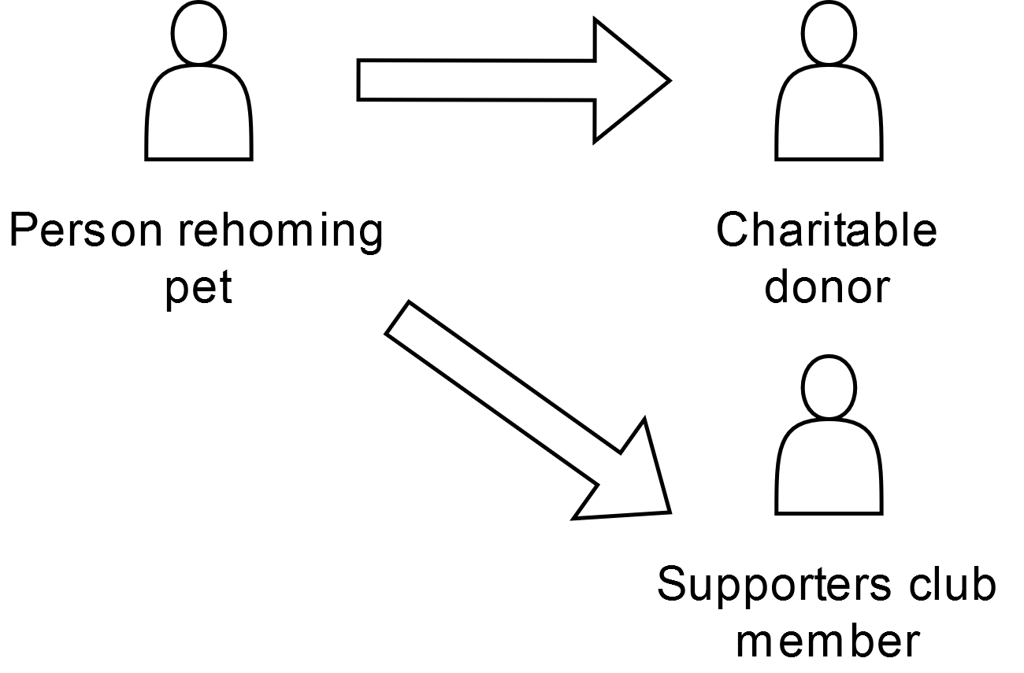

A rehomer becoming a charitable donor or supporters club member over time

The secondary key user group are charitable donors as contribute to Preloved Pets’ funds. These users are required for continued operation. The charitable donors goal is to donate to Preloved Pets. This user may have been a pet lover, or a rehomer, or simply a charitable person.

The donor gifting their will is a distinct user group. Their goal is to gift a (portion) of their will to Preloved Pets. They are separate to charitable donors due to the nature of the donation. This user group may be an older demographic, which should be considered in the website’s design and tone

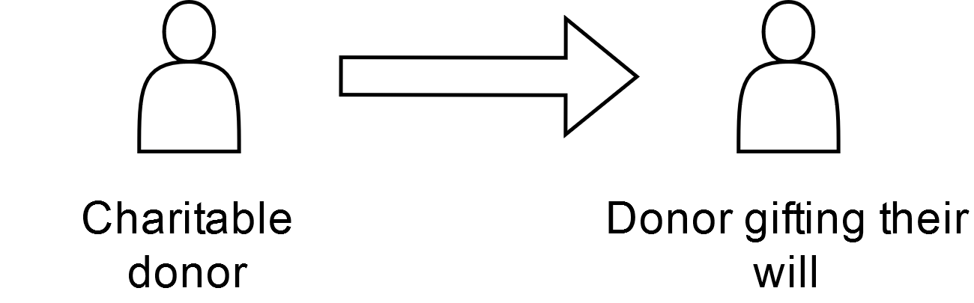

Charitable donor becoming a will donor over time

The final key user group is supporters club member. The supporters club member is a subset of charitable donor. However, their goals are slightly different. The club members want to donate to access the club and view the special magazine. They are regular users of the website.

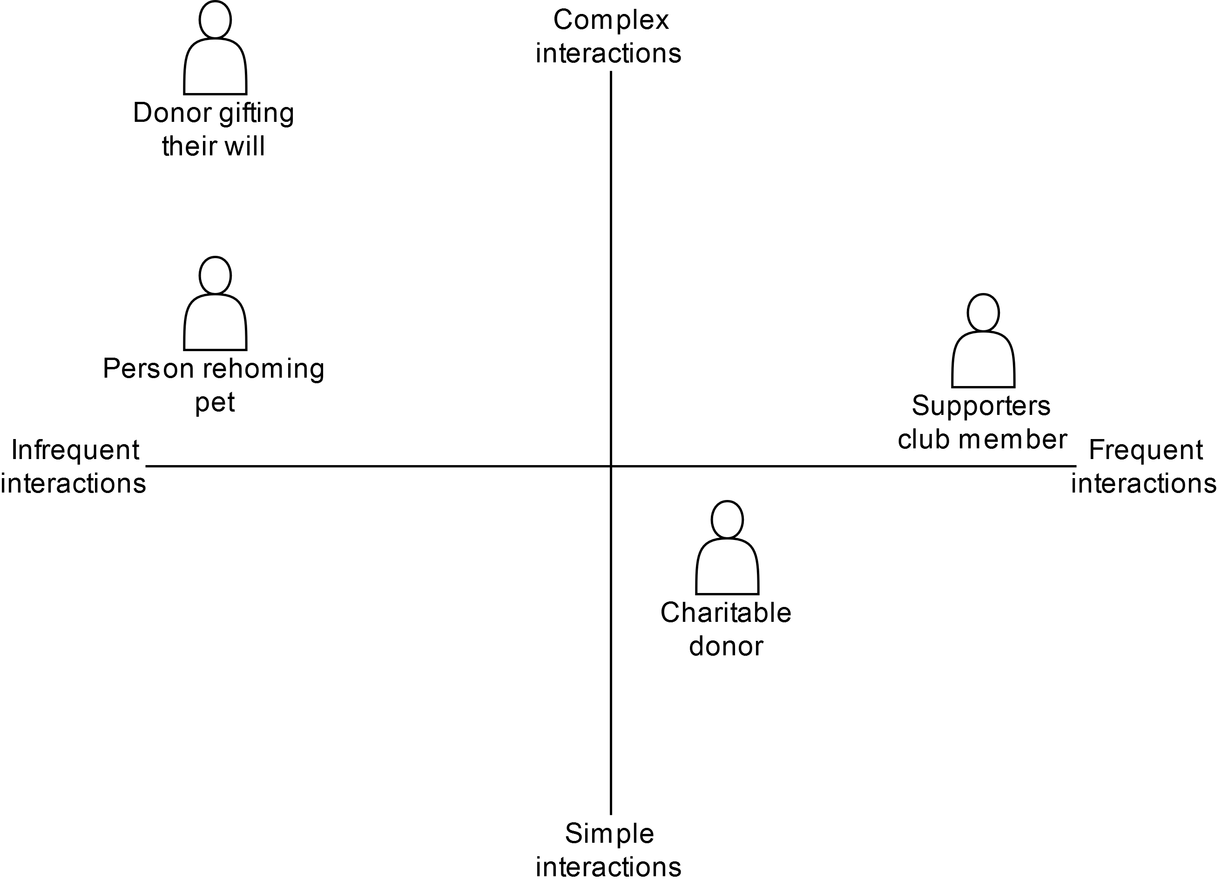

2x2 key user group summary view

### Personas

Summary view,

| Details | Primary persona |
| --- | --- |
| Image | Image of Rhys Thomas |
| Name | Rhys Thomas |
| Age | 35 |
| Location | Porthcawl, Bridgend |
| Occupation | Self-employed electrician |
| Life stage | Married with 2 children |
| Description | Rhys is self-employed electrician with a house and fostering family. In his early 20s he married and now has 2 children, aged 6 and 7. He wants what is best for his family. Since he is self-employed with children, he lacks time due to his busy schedule. |
| Owns pets | No |
| Digital literacy | Rhys owns a phone, and a laptop he uses for his electrical business. He has basic IT skills in Microsoft Office that he uses for his business. |
| Web usage | Rhys uses E-commerce regularly and checks the news when he has time. |
| Life goal | Rhys wants to make his family happy and do what is best for them. |
| Trigger | Rhys’s children have been desperate for a pet dog over the past year. However, he is worried it might be a fad for his children. |
| End goal | Rhys wants to get a pet dog for his children in a quick, no-nonsense manner |

| Details | Secondary persona |
| --- | --- |
| Image | Image of Dafydd Jones |
| Name | Dafydd Jones |
| Age | 40 |
| Location | Pyle, Bridgend |
| Occupation | Asda Manager |
| Life stage | Single with no children |
| Description | Dafydd is self-employed electrician with a house and fostering family. In his early 20s he married and now has 2 children, aged 6 and 7. He wants what is best for his family. Since he is self-employed with children, he lacks time and a busy schedule. |
| Owns pets | 1 cat |
| Digital literacy | Dafydd only owns a phone. He has not used a desktop computer since school. |
| Web usage | Dafydd uses social media on his phone regularly. |
| Trigger | Dafydd was driving to work when he heard a radio advertisement about Preloved Pets. Dafydd loves his cat and other pets so he decided to make a one-off donation of £10 to Preloved Pets |
| End goal | Dafydd wants to make a one-off donation to Preloved Pets |

| Details |  |
| --- | --- |
| Image | Image of Dafydd Jones |
| Name | Ieuan Tomos |
| Age | 81 |
| Location | Cornelly, Bridgend |
| Occupation | Retired |
| Life stage | Married with 3 children and 5 grandchildren |
| Description | Ieuan is an 81-year-old pensioner. Ieuan and his wife remain fiercely independent, and very active within the community despite their age. He started work in Port Talbot Steelworks, but then worked as a Police Officer, and finally a guard in the Royal Mint. However, recently Ieuan experienced some small health issues, inspiring him to rethink his will. He wants to leave large portion for his children and grandchildren, but he has decided to set aside some money for charitable causes. |
| Owns pets | None, but used to have several dogs |
| Digital literacy | Very little. Ieuan used computers for a short time before retirement. He owns a mobile phone which he uses for phone calls. For his emails, Ieuan uses a tablet, on account of his eyesight. |
| Web usage | Extremely little. Ieuan accesses a basic email account for communication, but nothing else. |
| Trigger | Ieuan saw a Preloved Pets advert in the local newspaper. |
| End goal | Gift a portion of his will to Preloved Pets |

| Details |  |
| --- | --- |
| Image | Image of Ceri Davies |
| Name | Ceri Davies |
| Age | 28 |
| Location | Bridgend, Bridgend |
| Occupation | Software Developer |
| Life stage | Engaged with no children |
| Description | Ceri Davies is a software developer. She lives with her fiancé who she has recently bought her first house with. She studied computer science in university and proceeded to get a job as a software engineer. Both Ceri and her finance love cats. They raised their first cat from kitten, and their second was rehomed from Preloved Pets. They both want what is best for their cats. |
| Owns pets | 2 cats |
| Digital literacy | Very good digital literacy. Ceri has a desktop, laptop, and phone, all of which she uses extensively |
| Web usage | Ceri Davies uses the web extensively |
| Trigger | One of Ceri’s cats was rehomed from Preloved Pets. Due to her experience, she wants to support Preloved Pets regularly and view the newsletter photos. |
| End goal | Ceri wants to sign up to the supporters club |

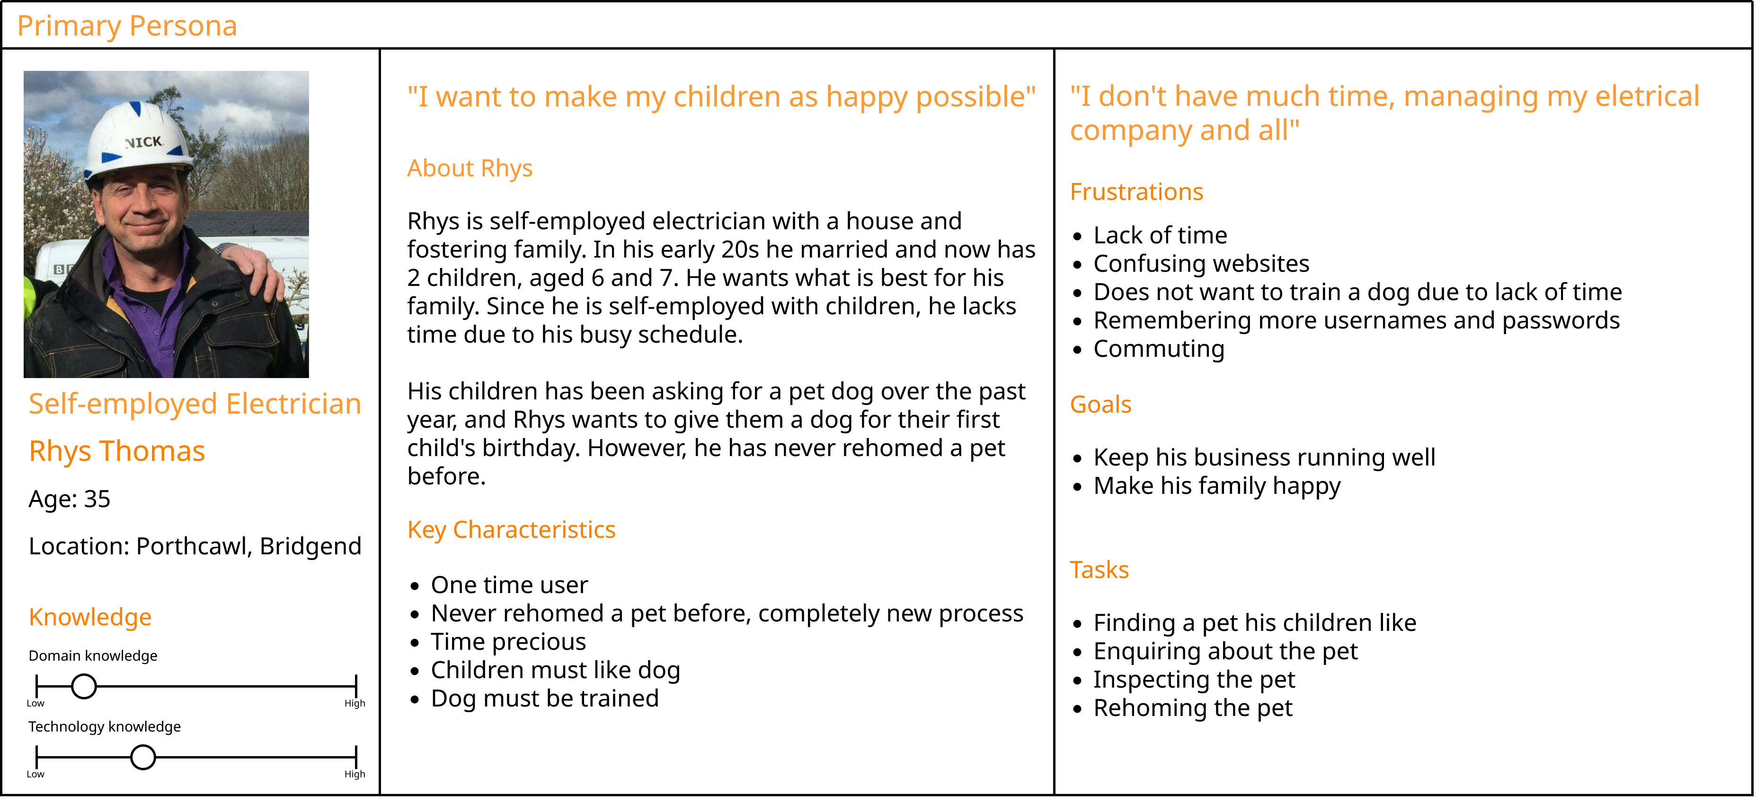

Rhys Thomas persona diagram

### Scenarios

#### Rhys Scenario

Over the past year, Rhys’ children have been begging for a pet dog. Rhys wants to surprise his eldest child on their birthday by gifting them a dog, hoping that they will take care of it. When commuting to his clients, Rhys listens to the local radio, repeatedly hearing adverts for Preloved Pets. After work, he googles the charity on his phone, and visits their website. Preloved Pets website highlights pets available for rehoming and Rhys finds a dog her daughter would like. He clicks on the enquire button for the dog. The enquire button organises an email conversation with Preloved Pets and Rhys is provided with a booking. He is linked to the contact us page, where he finds Preloved Pets’ location on Google Maps. On the booking day, Rhys uses the Google Maps directions to commute to Preloved Pets, where he inspects the dog, and decides to rehome it. When finishing the process, Rhys is shown Preloved Pets news area. The news area contains beginner articles on dog care, and Preloved Pets donation goals.

## Personality and Tone

### Design Principles

Prior to wireframing, several design principles were created based on the Preloved Pets personas. The principles were made to be short, informal, and memorable.

#### Quick experience

This principle aims to reduce the user’s time filling in complicated forms on the website. Nobody wants the experience of filling in a forms and correcting its validation errors only to reach another form afterward. This sentiment was echoed by our primary persona, Rhys Thomas.

The outcomes are:

* Forms should be a single page
* Form controls should be set automatically where possible.
* Preloved Pets’ website must be not fatiguing to navigate

#### A love for pets

Preloved Pets’ love for all pets needs to be clear. Extensive pet imagery and emotive language should be used throughout the entire website. This imagery includes: volunteers surrounded by pets, both cats and dogs playing, and comfortable facilities. Words such as ‘friends’, ‘love’, ‘companions’, and ‘adore’ should used in the website’s content.

The outcomes are:

* Emotive language about pets
* Usage of pet imagery throughout entire website
* Show a human connection with pets. This includes playing, hugging, resting, and feeding pets

#### Part of the community

Preloved Pets is a charity that is self-funded by the community. The community’s role in Preloved Pets daily running must be shown. This can be shown through community imagery, direct language using pronouns such as, ‘you’, ‘we’, ‘our’, and ‘us’, creating news articles about local pets, and calls to donate or volunteer using local people or organisations.

The outcomes are:

* Community imagery
* Use of direct language
* Local news articles

#### It’s charity, not business

At all times, the website should highlight that Preloved Pets is a local charity; it relies on donations and volunteers. There should be widespread calls to volunteer or donate, utilising emotive language and incentives to persuade people. Rather than business terms, charitable language should be used. ‘Volunteer’ should be written instead of ‘staff’ and donors, volunteers, and advertisers should be regularly thanked for their contributions.

The outcomes are:

* Frequent calls to action
* Never use business language
* Regularly thank people for their help

#### Accessible to everyone

There are 16.1 million disabled people in the United Kingdom, accounting for 24% of the total population (Kirk-Wade et al., 2025). An inaccessible website can damage the user’s experience or completely prevent a person using the website. To ensure all donors and users can use Preloved Pets’ service, Web Content Accessibility Guidelines (WCAG) Level 2 (AA) will be followed. Notable guidelines include: colour contrast, including alternate text, heading hierarchies, non-descriptive links, and bad keyboard navigation.

The outcomes are:

* Follow WCAG AA

### Mood Board

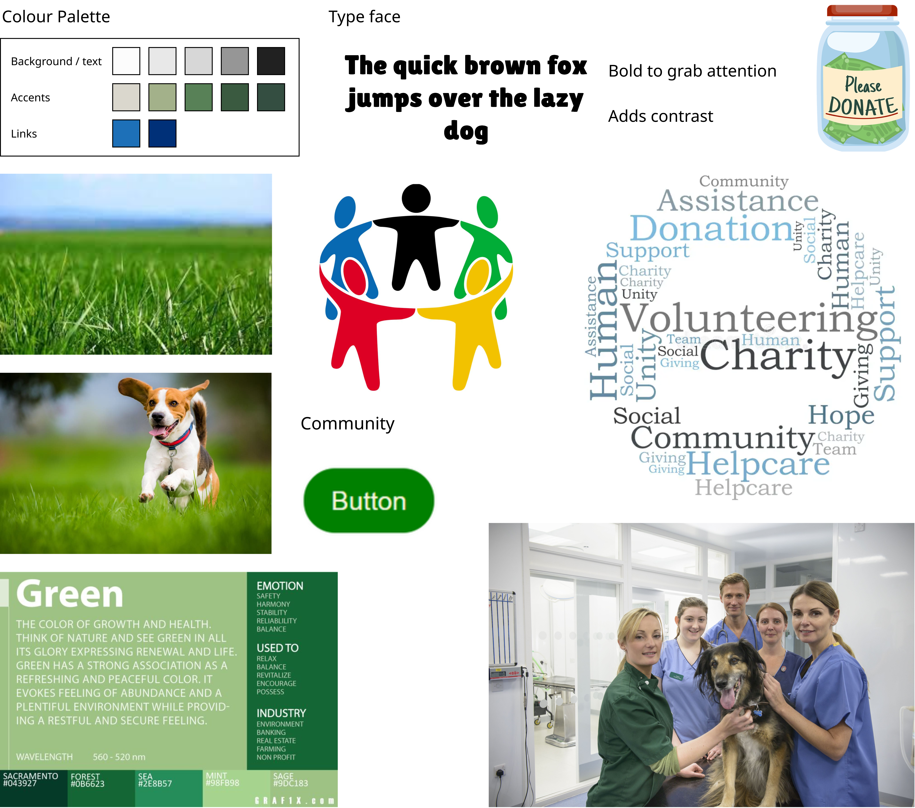

Mood board

### Wireframes

A large amount of the personas will be accessing the website using mobile devices; therefore, it is important that website accessibility remains consistent across both desktop and mobile form factors. To achieve this, both a desktop and mobile wireframe and flow will be created for all pages.

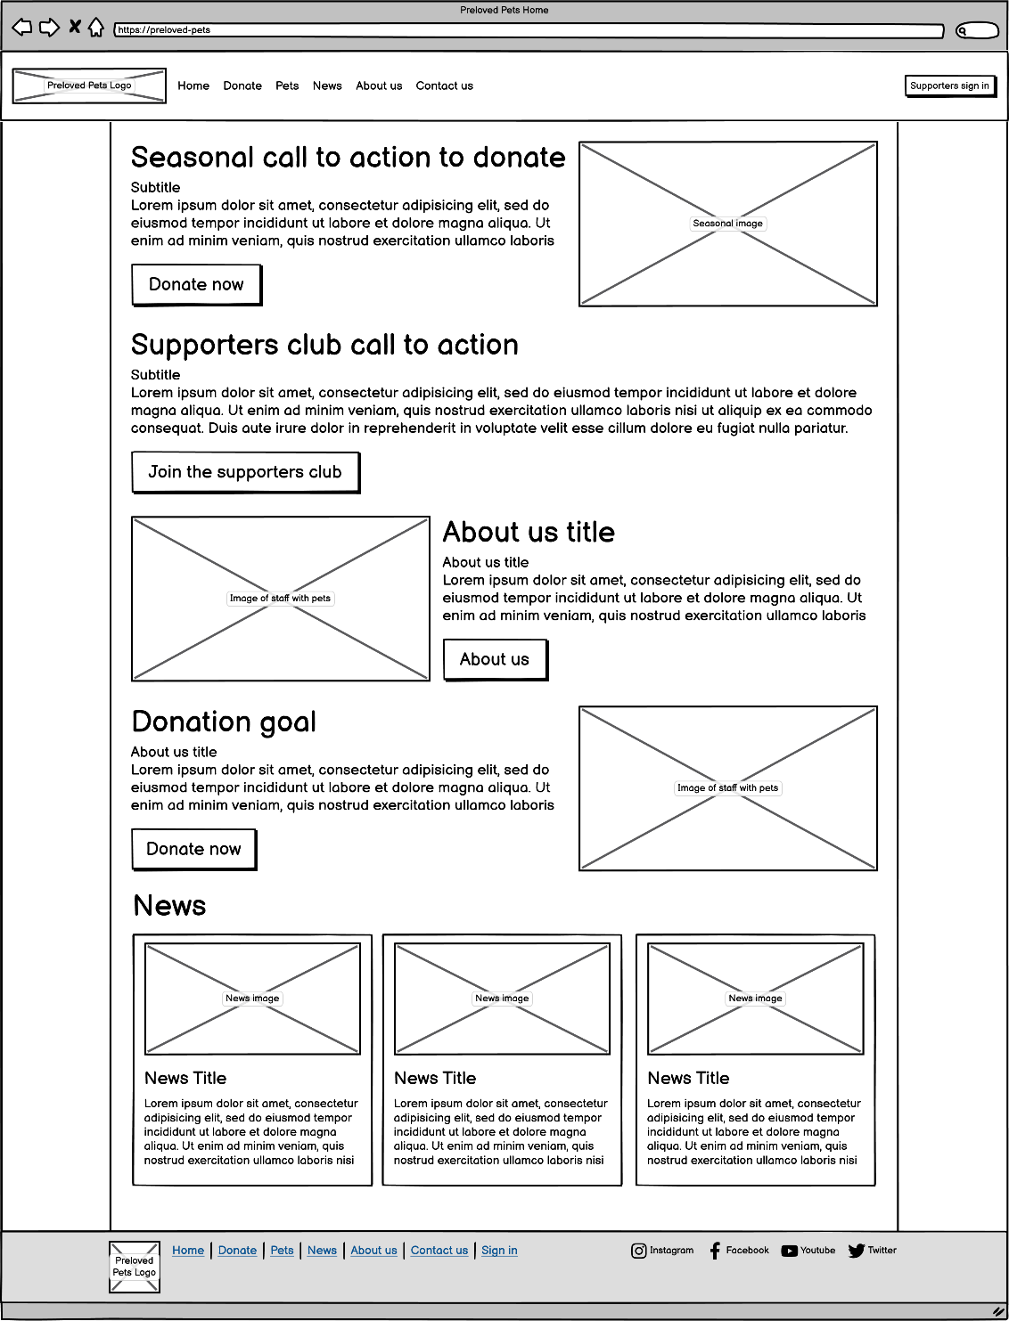Homepage,

Desktop homepage

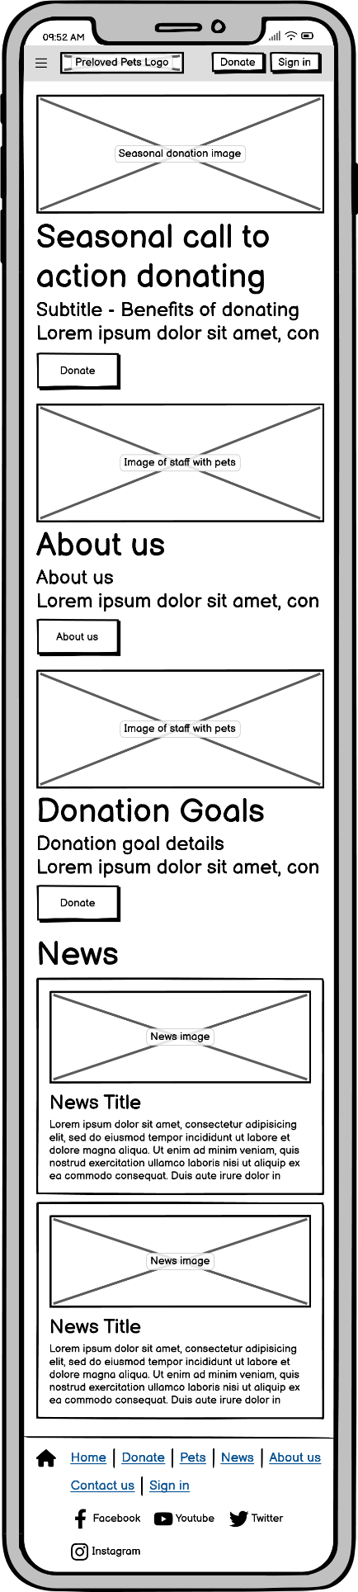

Mobile homepage

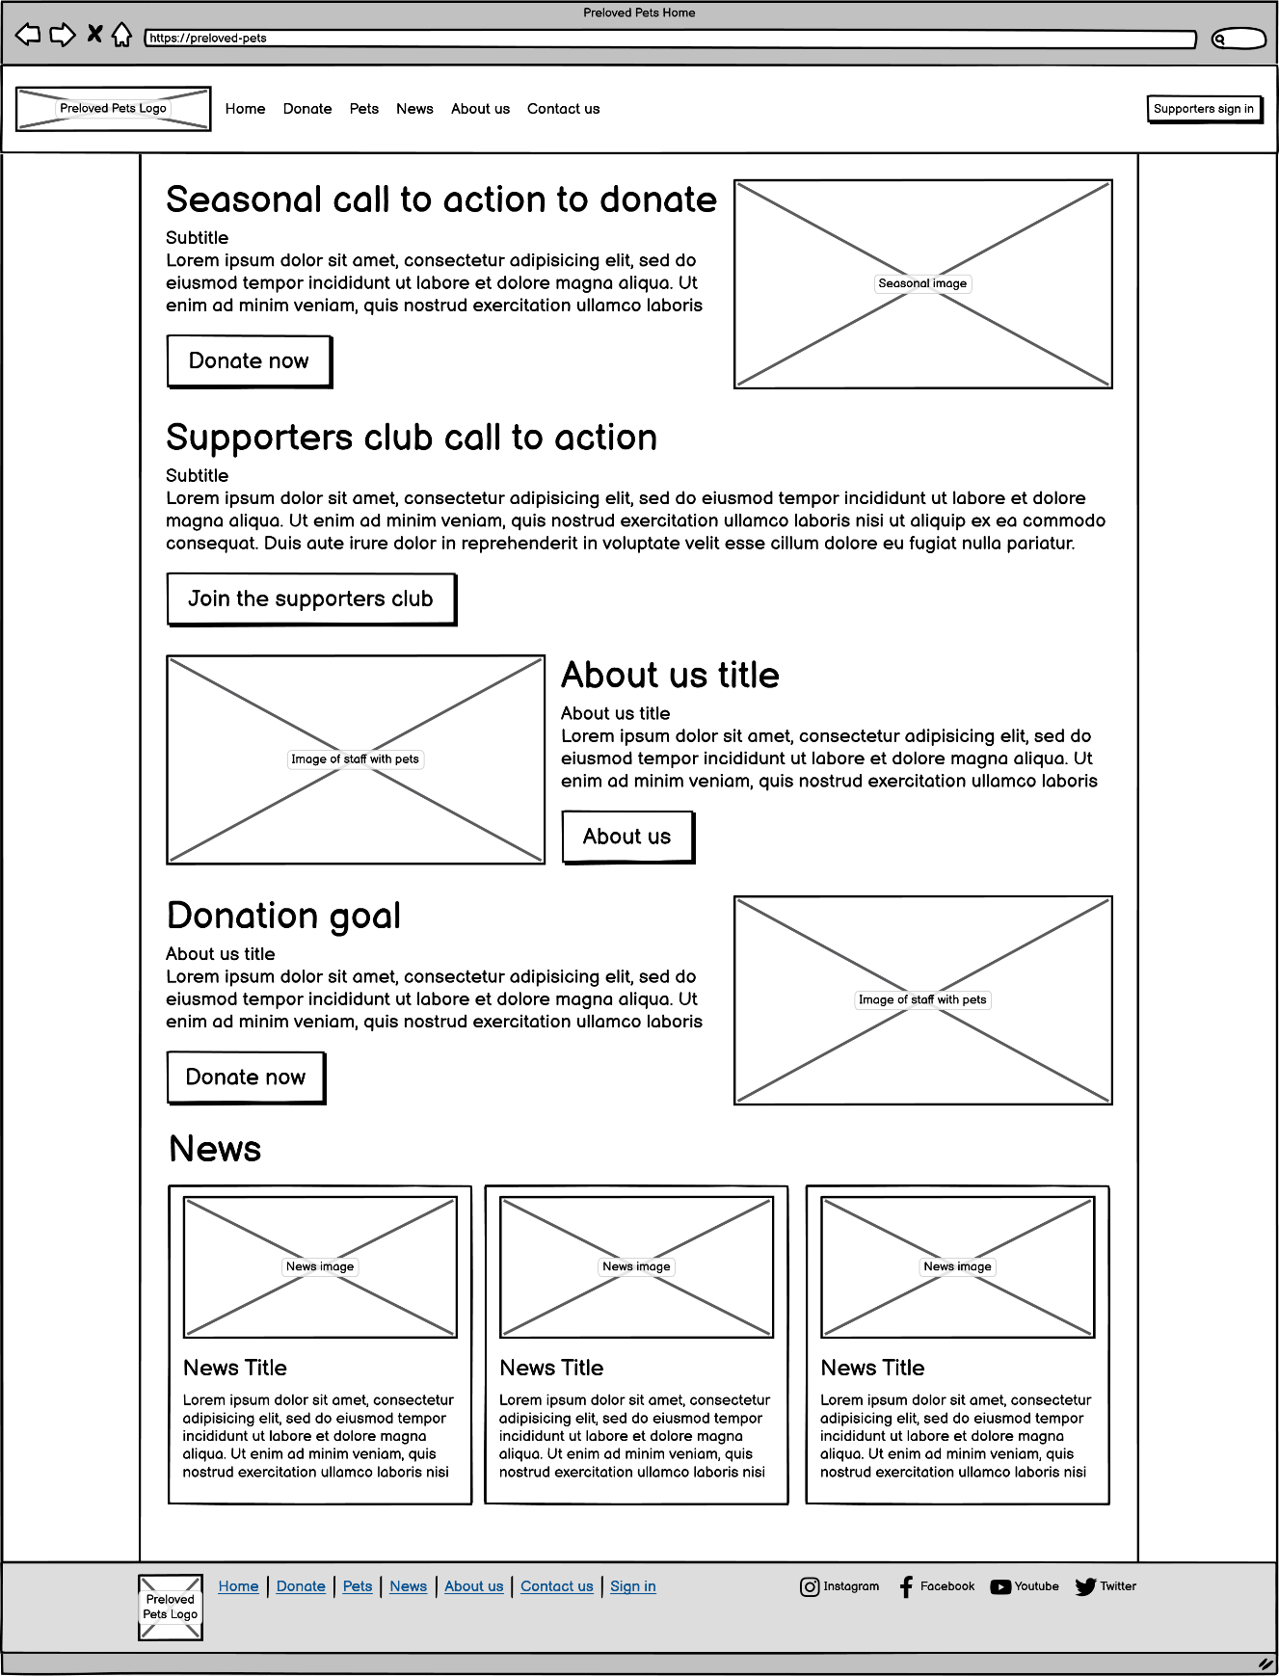Donation page,

Desktop donation page

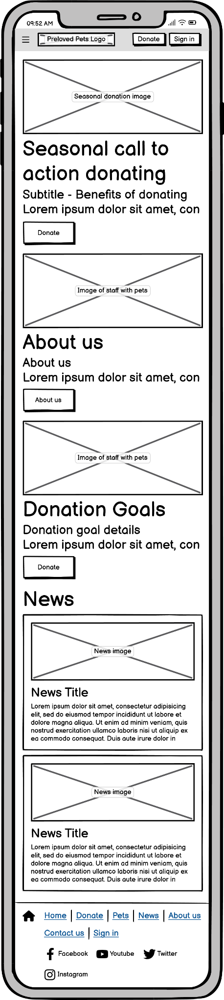

Mobile donation page

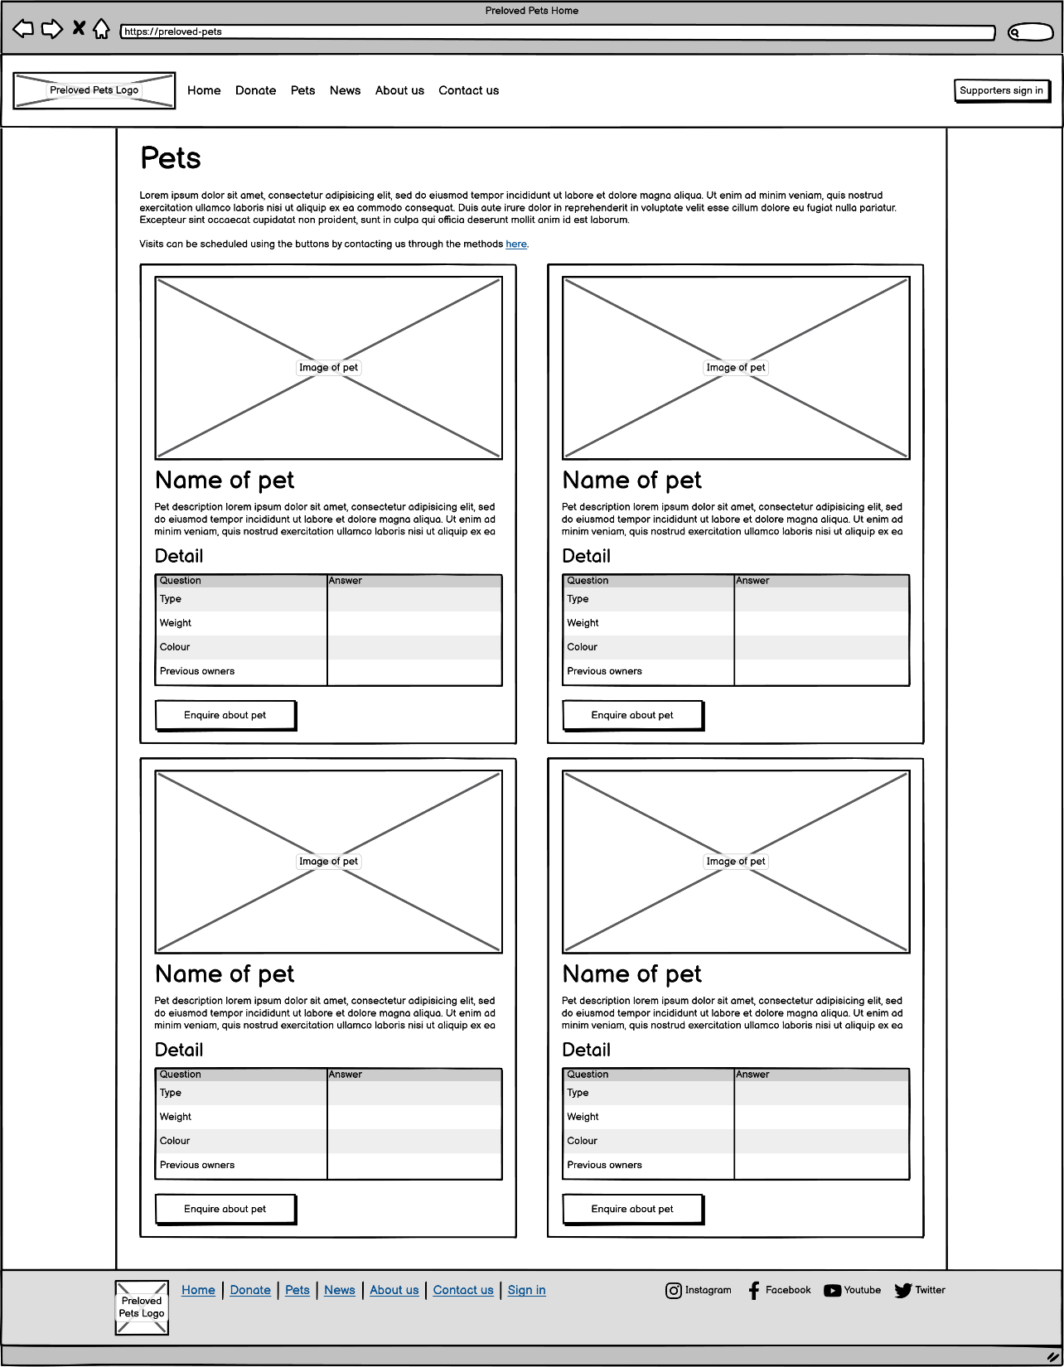Pets page,

Desktop page

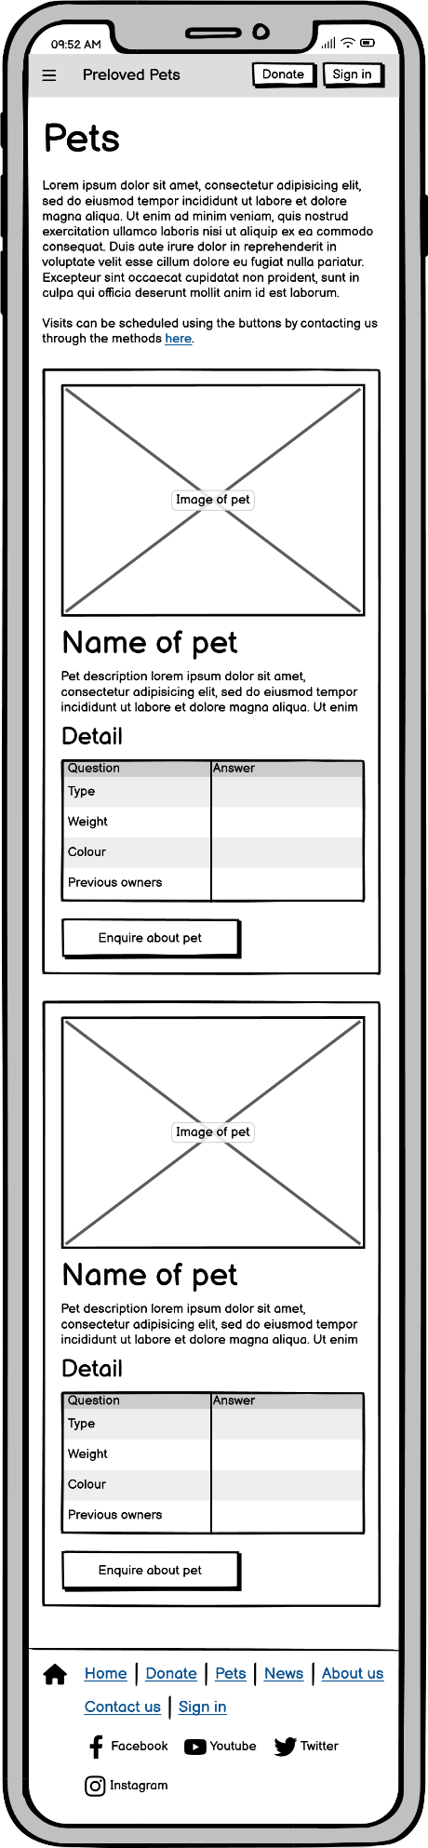

Mobile page

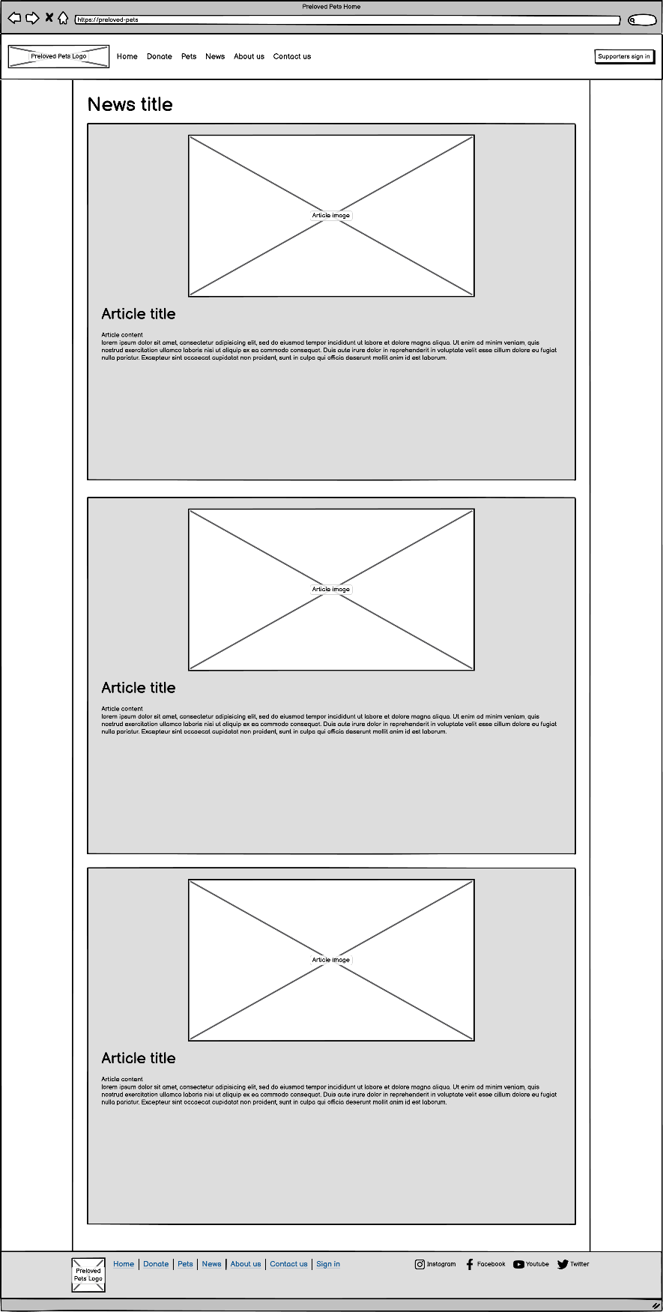News page,

Desktop news page

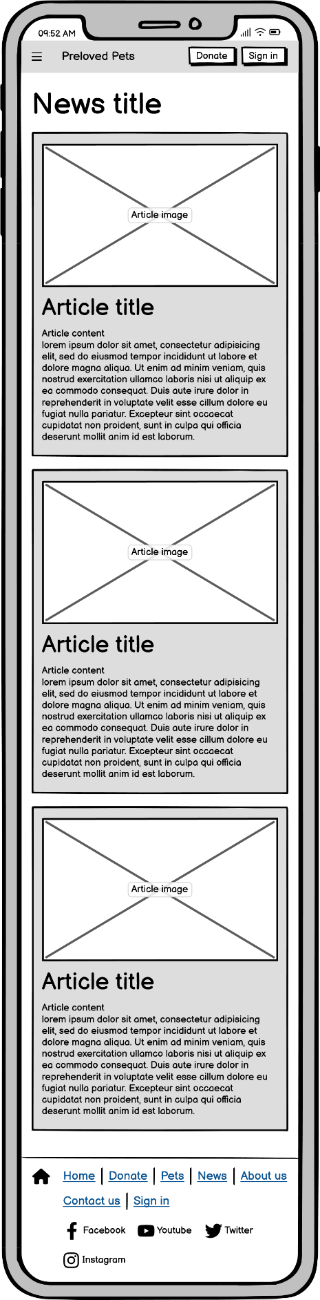

Mobile news page

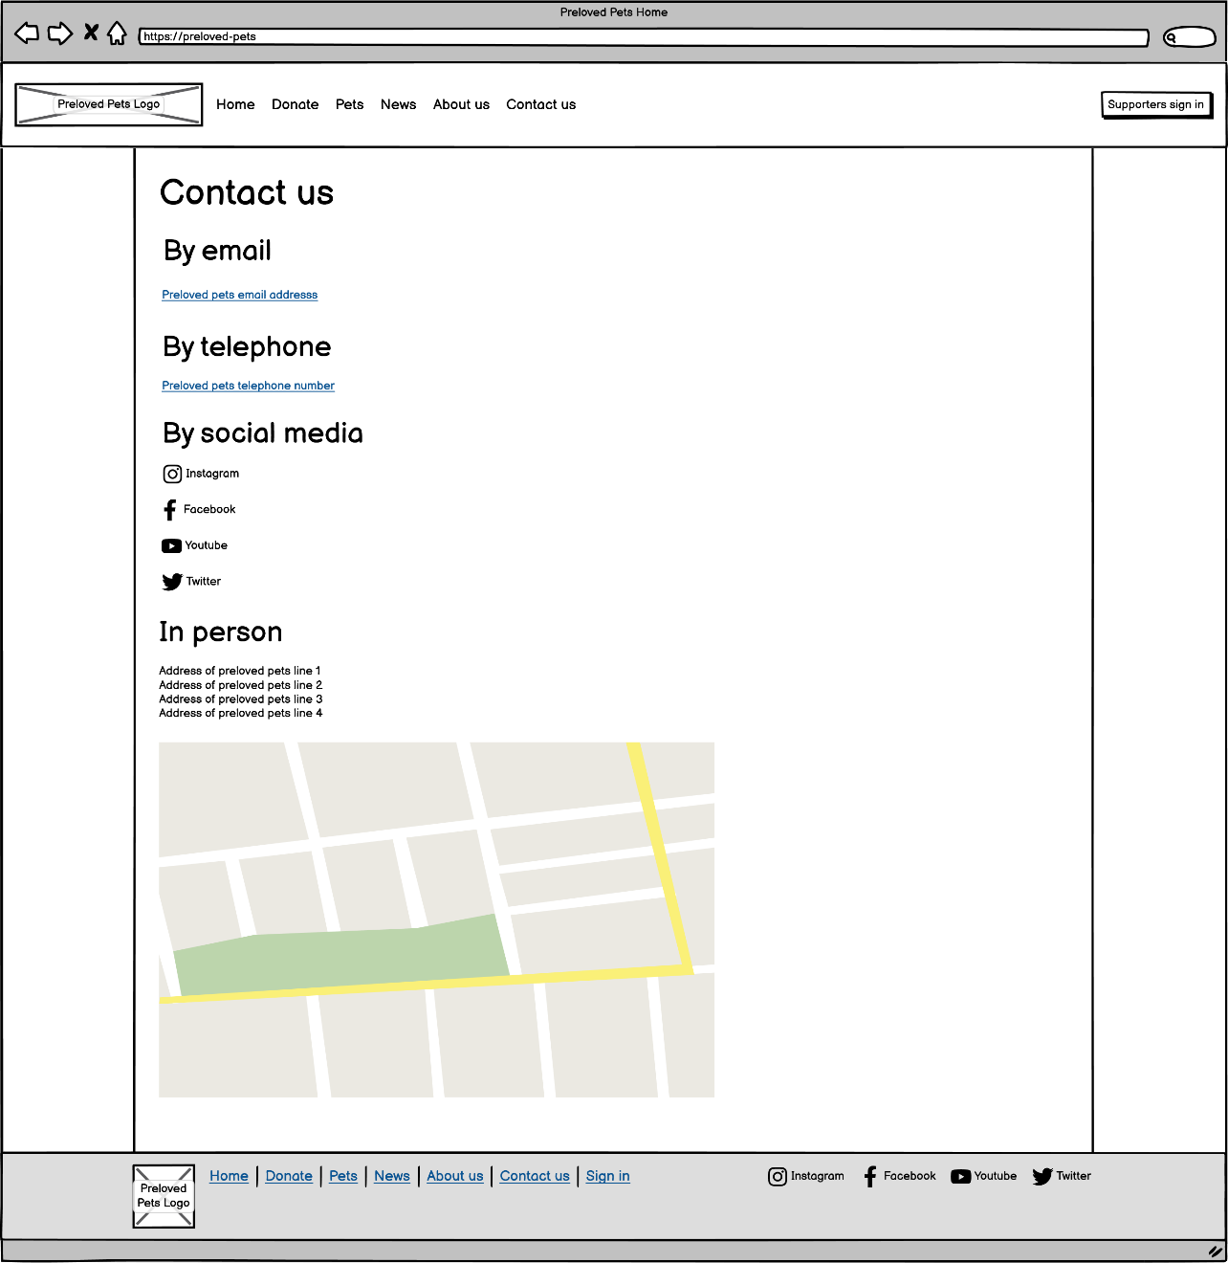Contact us page,

Desktop contact us page

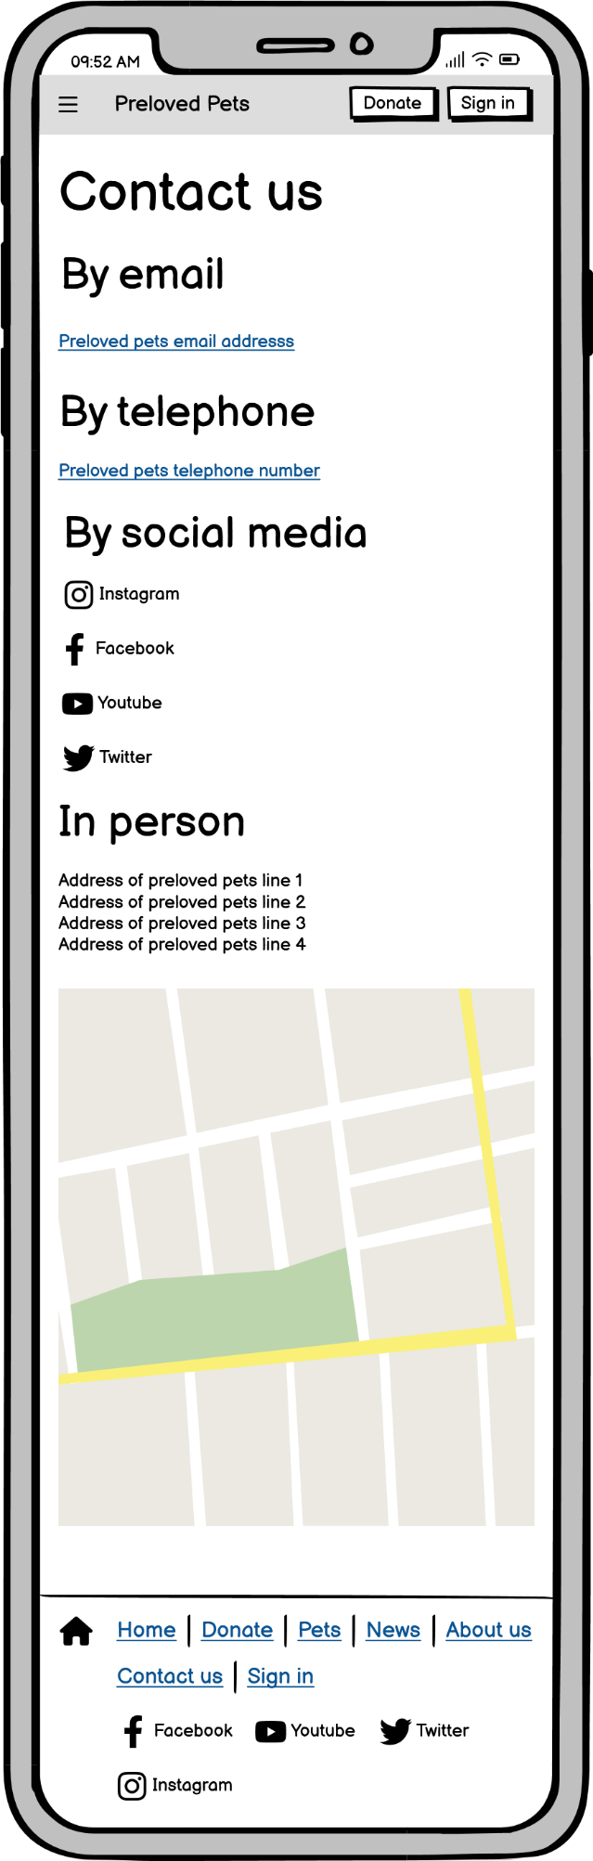

Mobile contact us page

About us page,

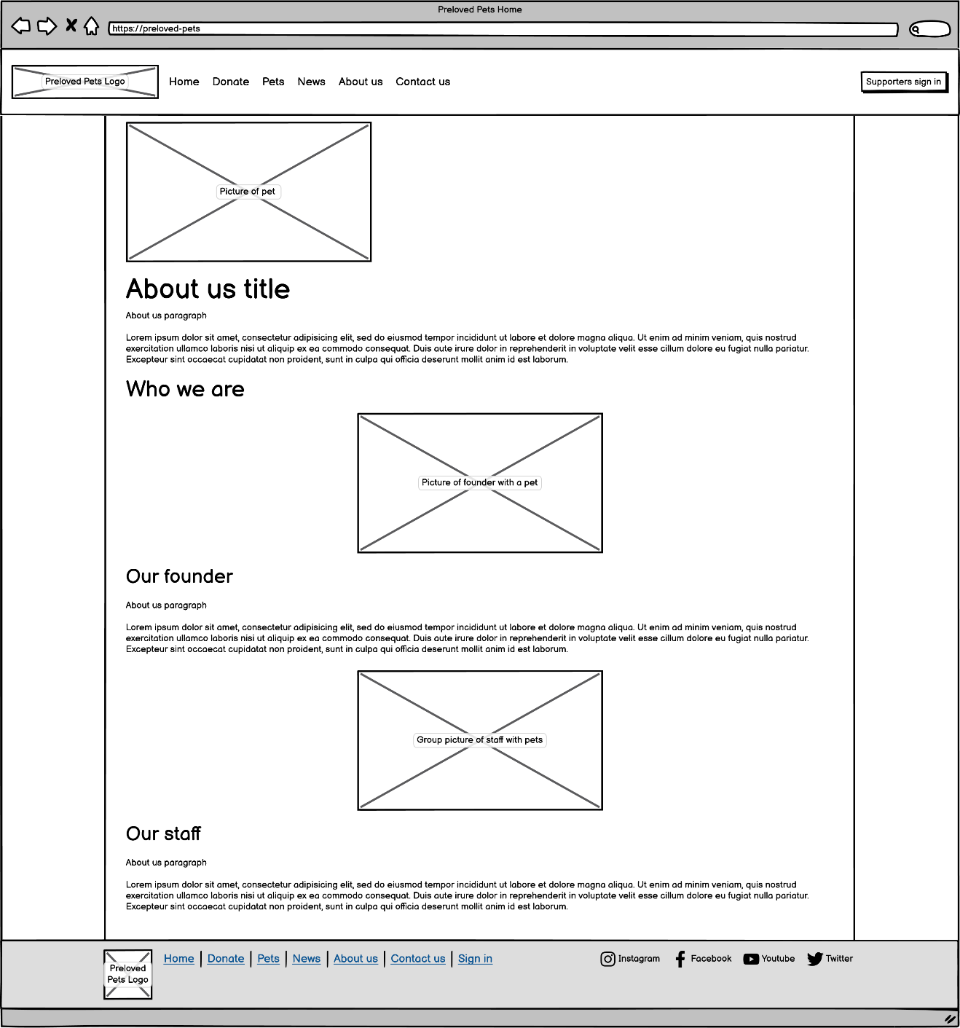

Desktop about us page

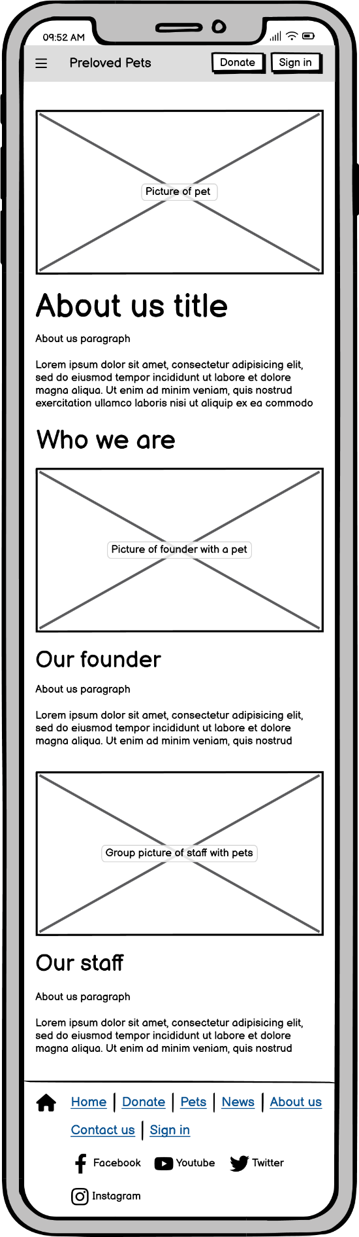

Mobile about us page

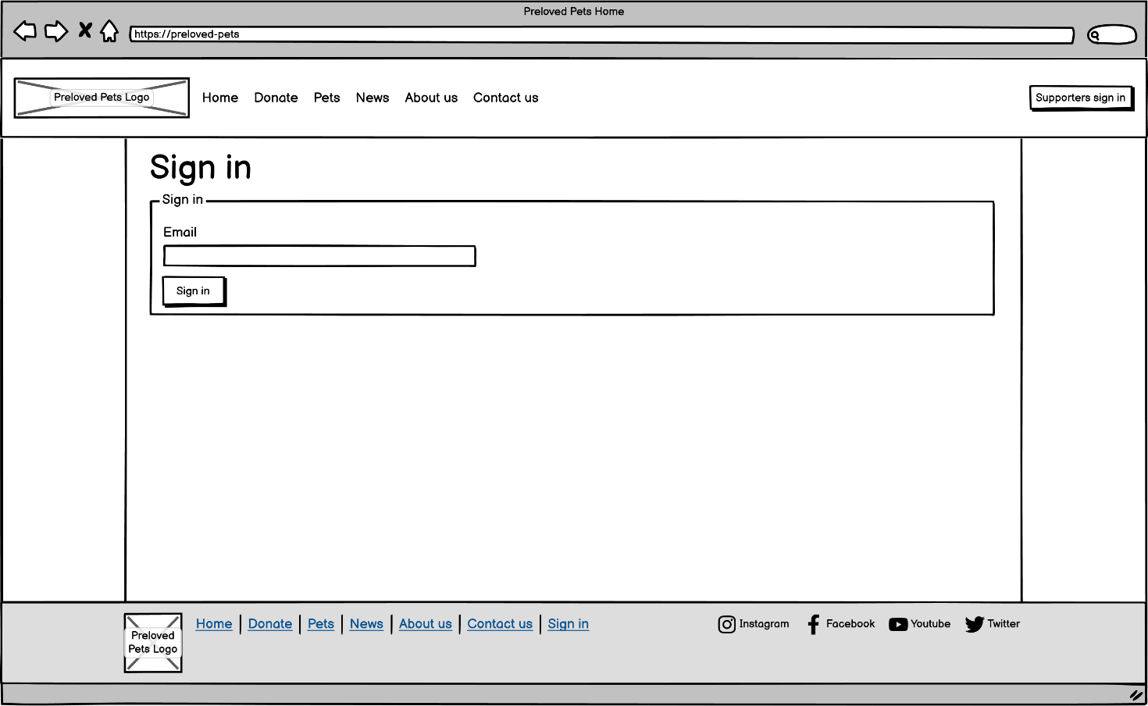Supporter club sign in page,

Desktop sign in page

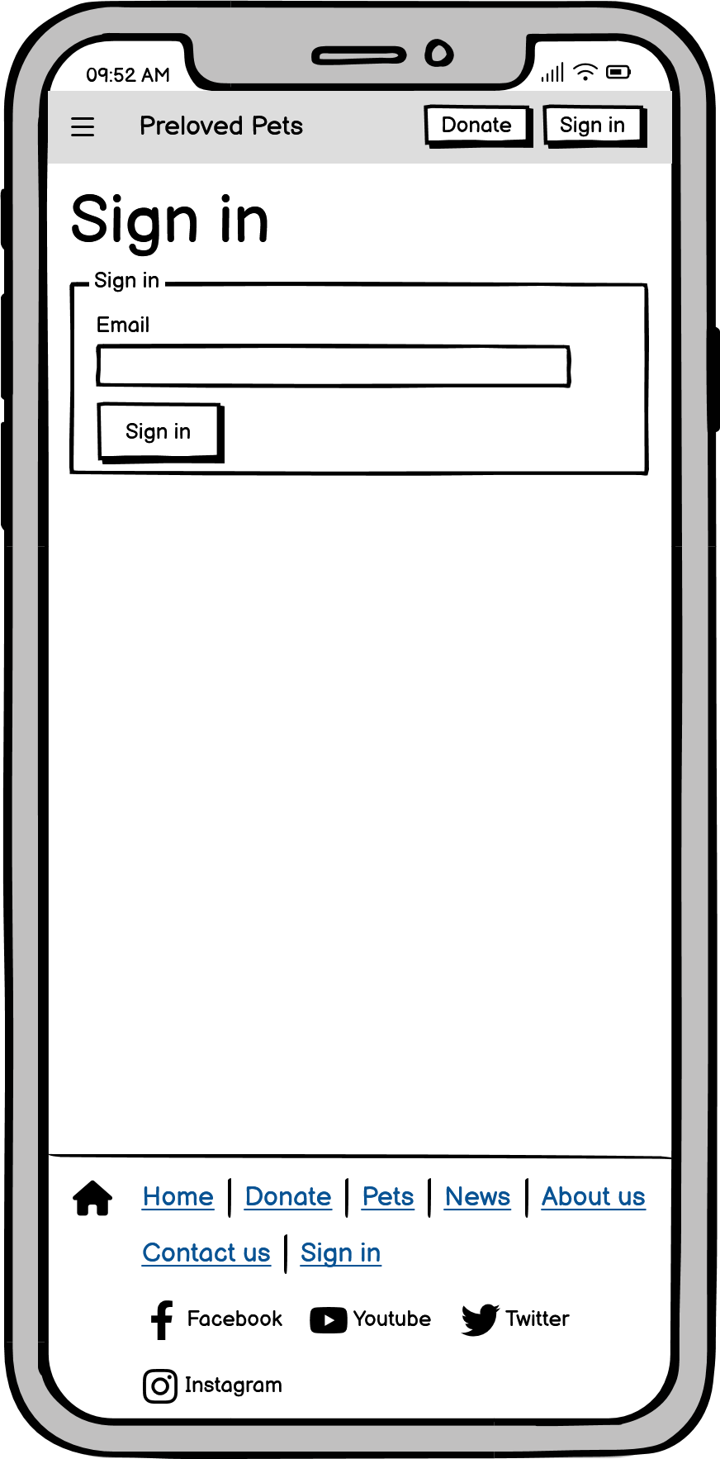

Mobile sign in page

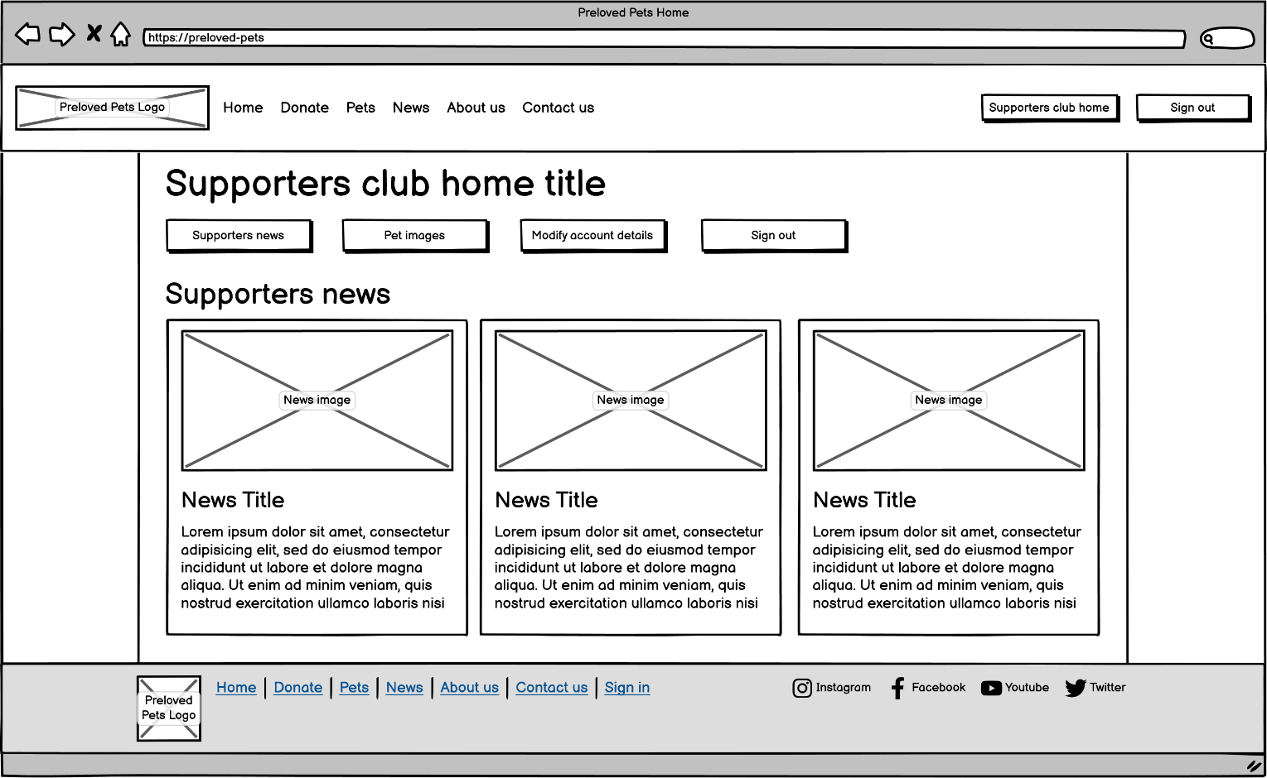Supporters club home page,

Desktop supporters club home page

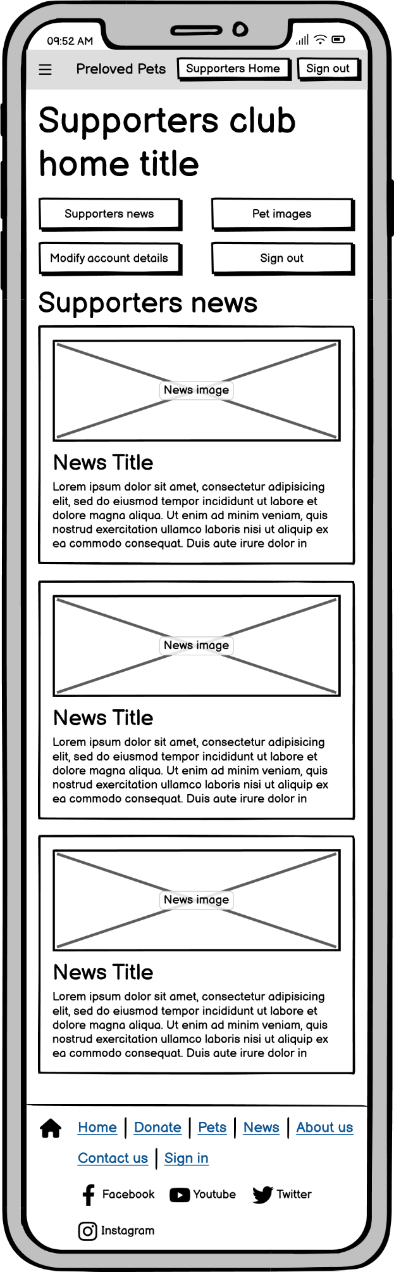

Mobile supporters club home page

### Wireflows - Storyboards

#### Donation wireflows

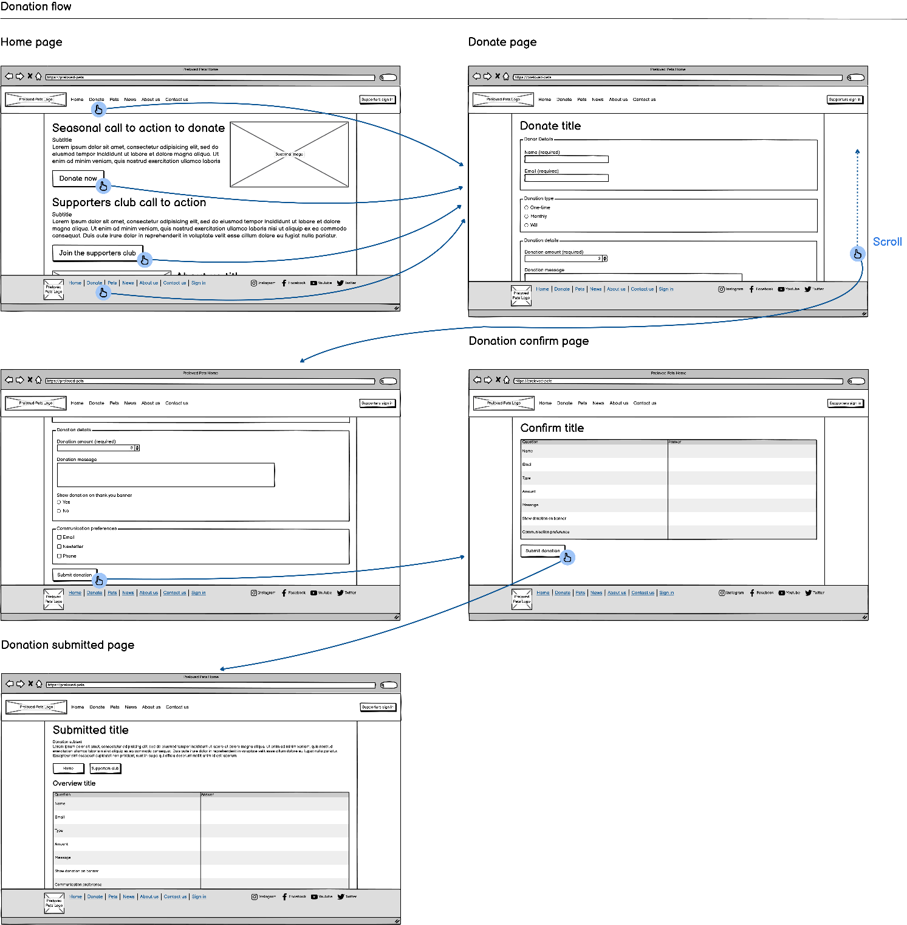Desktop donation wireflow

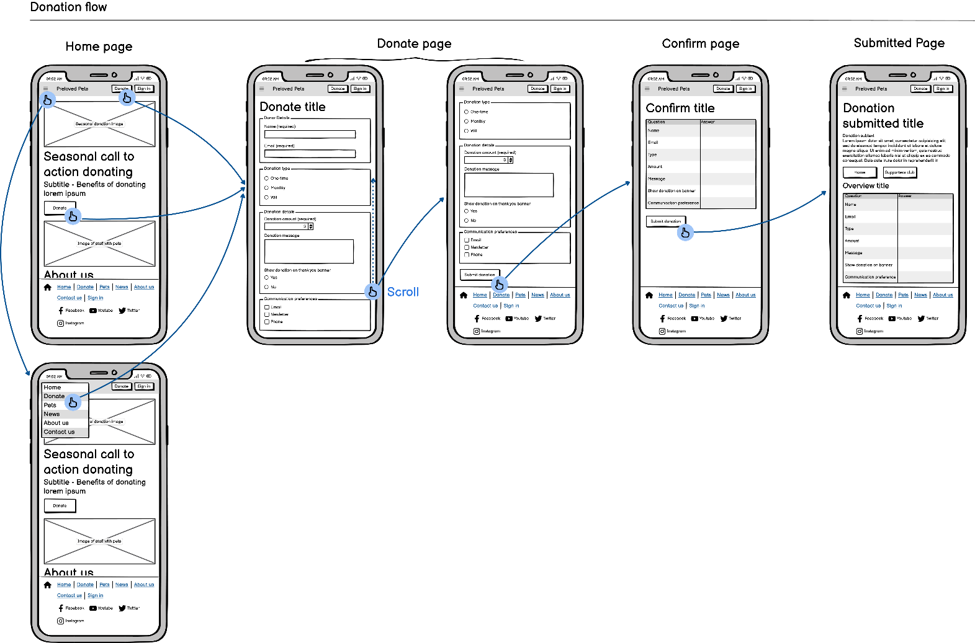Mobile donation wireflow

#### 

#### Desktop rehome wireflowRehome pet flow

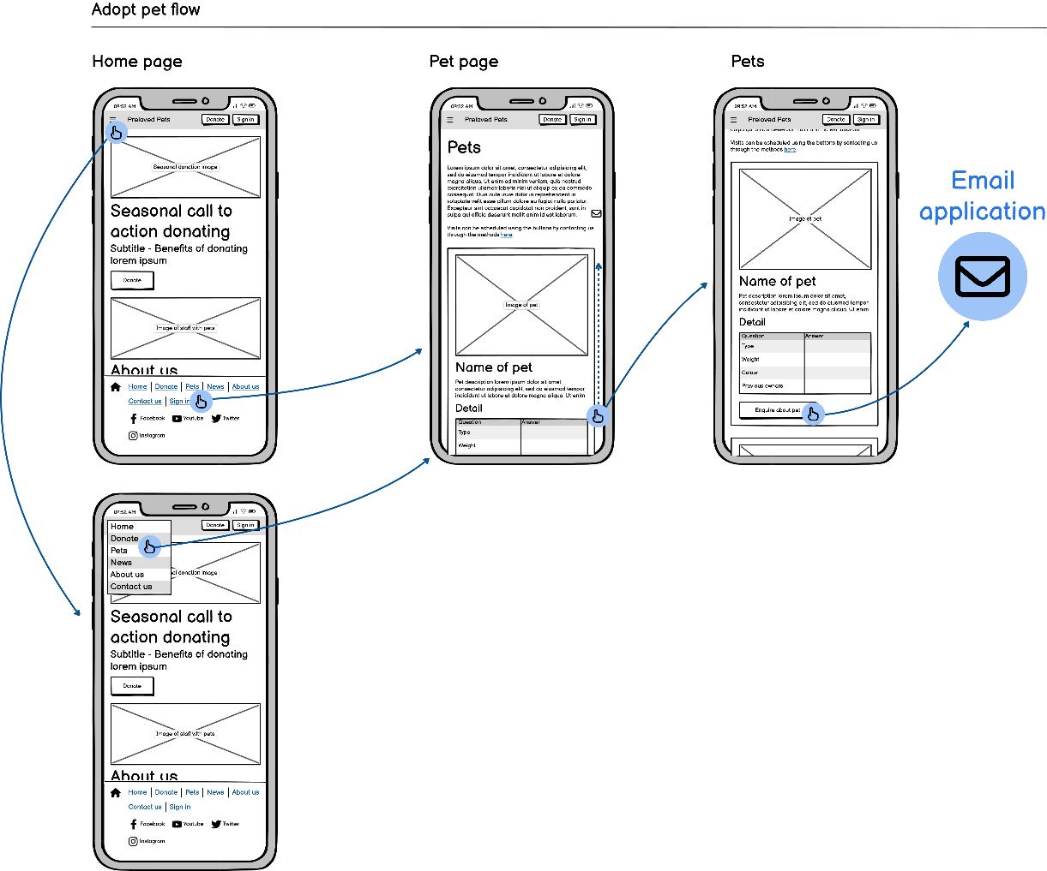Desktop rehome wireflow

Mobile rehome wireflow

#### Desktop sign in wireflowSign in flow

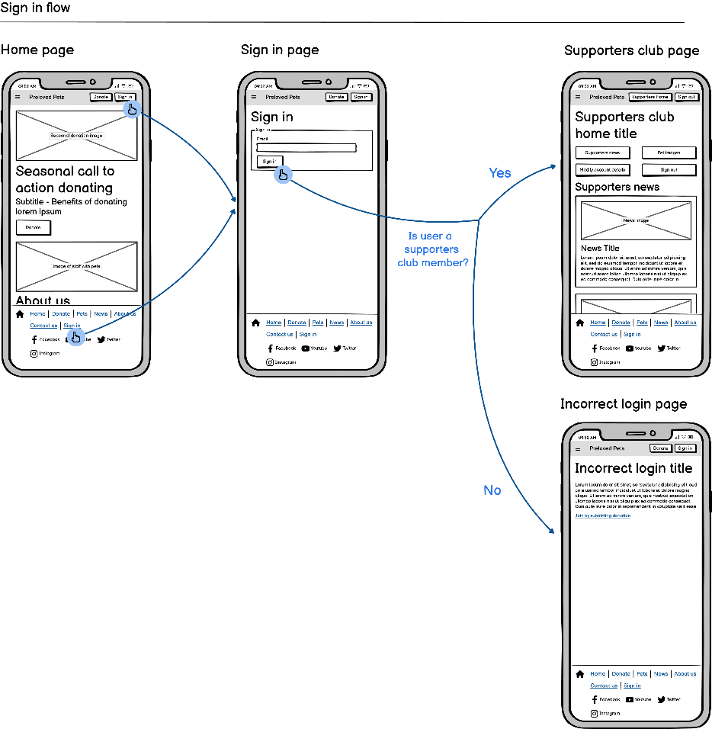Desktop sign in wireflow

Mobile sign in wireflow

##### Desktop update supporter account detailsUpdate supporter account details flow

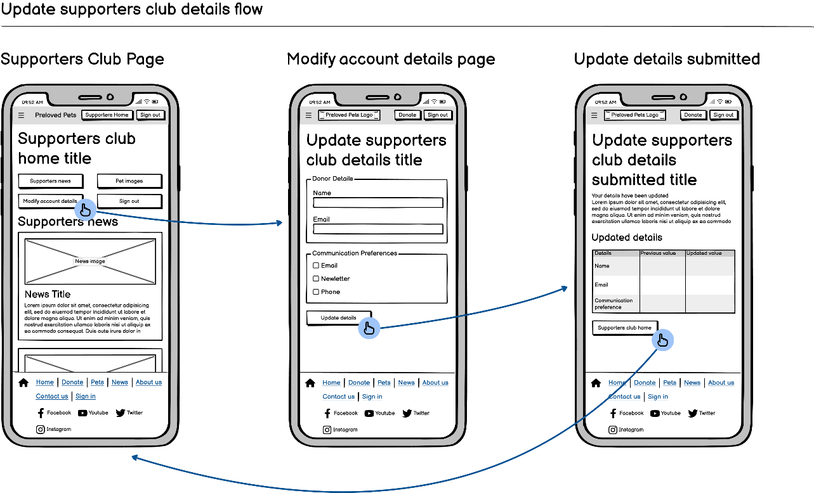Desktop update supporter account details

Mobile update supporter account details

## Persuasive Tactics

As Preloved Pets is funded by donations, persuasive tactics must be used to convince potential donors. Extensive usage of direct address will be used through using words such as ‘you’, ‘us’, and ‘we’ to connect with users on a personal level. Additionally, emotive language will be used to provoke a sympathetic, caring response towards Preloved Pets goals.

Furthermore, several active techniques will be used. On the home and donation pages, a variation of self-monitoring will be used. However, the goals will be community-based rather than personal. A live money counter will show progress towards donation milestones such as reptiles and fish enclosures. The goal is inspiring a sense of community and achievement. In addition, Preloved Pets’ homepage will be updated with periodic banners and calls to donate, containing specialised images and language. Periodic events include Christmas, Easter, Halloween, Mother’s Day, Valentines, New Year, and St Davids Day. Finally, social proof will be used to reinforce the other persuasive tactics. Below Preloved Pets’ header, a scrolling donation bar will be added. Donations that opt into the bar will be displayed with custom message and donation amount. All incoming users will see this bar and all the different people who donated and reflect their behaviour, increasing the amount of donations to Preloved Pets.

## Single Minded Message

Preloved Pets single-minded message will combine the website’s goals, advertising pets for rehoming, and increasing funding through donations. The phrase, ‘help us give pets a forever family’ combines these goals. ‘Help’ refers to donating and ‘giving pets a forever family’ generates an emotive, positive, and caring response about rehoming pets.

# Supporting Material

## Website URL

<https://ces-web2.southwales.ac.uk/students/23056792/index.php>

## PHP Page Listing

The entire website is PHP; therefore, the shown code listings are PHP-heavy files.

index.php,

<?php  
  
 use data\database;  
  
 require_once __DIR__ . "/data/database.php";  
 require_once __DIR__ . "/config/config.php";  
 // Require classes for session_start to avoid __PHP_Incomplete_Class  
 require_once __DIR__ . "/models/pet.php";  
 require_once __DIR__ . "/models/donation.php";  
  
 session_start();  
 $request = parse_url($_SERVER["REQUEST_URI"], PHP_URL_PATH);  
 $db = new database(DB_HOST, DB_NAME, DB_PORT, DB_USER, DB_PASS, DB_SOCK);  
 // Routing  
 switch ($request) {  
 case "":  
 case "/":  
 $view = __DIR__ . "/views/home.php";  
 break;  
 case "/donate":  
 $view = __DIR__ . "/views/donate.php";  
 break;  
 case "/pets":  
 $view = __DIR__ . "/views/pets.php";  
 break;  
 case "/contact-us":  
 $view = __DIR__ . "/views/contact-us.php";  
 break;  
 case "/about-us":  
 $view = __DIR__ . "/views/about-us.php";  
 break;  
 case "/news":  
 $view = __DIR__ . "/views/news.php";  
 break;  
 case "/donation/confirm":  
 $view = __DIR__ . "/views/donate-confirm.php";  
 break;  
 case "/donation/submitted":  
 $view = __DIR__ . "/views/donate-submitted.php";  
 break;  
 case "/supporters/signin":  
 $view = __DIR__ . "/views/supporters-signin.php";  
 break;  
 case "/supporters/home":  
 $view = __DIR__ . "/views/supporters-home.php";  
 break;  
 case "/supporters/update":  
 $view = __DIR__ . "/views/supporters-update-details.php";  
 break;  
 case "/supporters/update-submit":  
 $view = __DIR__ . "/views/supporters-update-details-submitted.php";  
 break;  
 case "/supporters/signout":  
 // Unset authentication  
 unset($_SESSION["supporter_details"]);  
 header("location:/");  
 // Redirect to home  
 break;  
 default:  
 header("location:/404");  
 http_response_code(404);  
 $view = __DIR__ . "/views/404.php";  
 break;  
 }  
?>  
<!DOCTYPE html>  
<html lang="en">  
 <?php require $view; ?>  
</html>

config.php,

<?php  
 const DB_HOST = "db";  
 const DB_PORT = 3306;  
 const DB_NAME = "mysql";  
 const DB_USER = "root";  
 const DB_PASS = "admin";  
 const DB_SOCK = "/var/run/mysqld/mysqld.sock";

database.php,

<?php  
 declare(strict_types=1);  
  
 namespace data;  
  
 use mysqli;  
  
 class database  
 {  
 private mysqli $conn;  
 private string $host;  
 private int $port;  
 private string $databaseName;  
 private string $user;  
 private string $password;  
 private string $sock;  
  
 public function __construct(string $host, string $name, int $port, string $user, string $password, string $sock)  
 {  
 $this->host = $host;  
 $this->databaseName = $name;  
 $this->port = $port;  
 $this->user = $user;  
 $this->password = $password;  
 $this->sock = $sock;  
 }  
  
 public function getConn(): mysqli  
 {  
 if (isset($this->conn)) {  
 return $this->conn;  
 }  
  
 $this->conn = new mysqli($this->host, $this->user, $this->password, $this->databaseName, $this->port, $this->sock);  
 if ($this->conn->connect_error) {  
 exit("Failed to connect to mysql database {$this->conn->connect_error}");  
 }  
 $this->conn->set_charset("utf8mb4");  
 return $this->conn;  
 }  
 }

donation_repo.php,

<?php  
 declare(strict_types=1);  
  
 namespace data;  
  
 use model\donation;  
  
 require_once __DIR__ . "/database.php";  
 require_once __DIR__ . "/../models/donation.php";  
  
 class donation_repo  
 {  
 public database $database;  
  
 public function __construct(database $database)  
 {  
 $this->database = $database;  
 }  
  
 /**  
 * @return array<donation>  
 */  
 public function get_banner_donations(): array  
 {  
 $donation_types = $this->get_donation_types();  
 $conn = $this->database->getConn();  
 $result = $conn->query("  
 SELECT donation_id,   
 donation_type_id,   
 donator_name,   
 donation_email,   
 donation_amount,   
 donation_message,  
 comm_preference,  
 show_billboard  
 FROM public.donation  
 WHERE show_billboard = 1   
 LIMIT 20"  
 );  
 $rows = $result->fetch_all(MYSQLI_ASSOC);  
 /** @var array<donation> $donations */  
 $donations = array();  
 foreach ($rows as $row) {  
 $new_donation = new donation(  
 intval($row["donation_id"]),  
 $donation_types[intval($row["donation_type_id"])],  
 $row["donator_name"],  
 $row["donation_email"],  
 floatval($row["donation_amount"]),  
 $row["donation_message"],  
 $row["comm_preference"],  
 boolval($row["show_billboard"])  
 );  
 $donations[] = $new_donation;  
 }  
 return $donations;  
 }  
  
 /**  
 * @return array<int,string>  
 */  
 public function get_donation_types(): array  
 {  
 $conn = $this->database->getConn();  
 $result = $conn->query("  
 SELECT donation_type_id, donation_type  
 FROM public.donation_type"  
 );  
 $rows = $result->fetch_all(MYSQLI_ASSOC);  
 /** @var array<int, string> $donation_types */  
 $donation_types = array();  
 foreach ($rows as $row) {  
 $donation_types[$row["donation_type_id"]] = $row["donation_type"];  
 }  
 return $donation_types;  
 }  
  
 public function add_donation(donation $donation): bool  
 {  
 $conn = $this->database->getConn();  
 switch ($donation->donationType) {  
 case "monthly":  
 $donation_type_id = 1;  
 break;  
 case "will":  
 $donation_type_id = 3;  
 break;  
 case "one-time":  
 default:  
 $donation_type_id = 2;  
 break;  
 }  
  
 $sql = $conn->prepare("  
 INSERT INTO public.donation  
 (donation_type_id, donator_name, donation_email, donation_amount, donation_message, comm_preference, show_billboard)  
 VALUES (?, ?, ?, ?, ?, ?, ?);"  
 );  
 // Convert to int before passing to database  
 $show_billboard_int = intval($donation->showBillboard);  
 $sql->bind_param("issdssi",  
 $donation_type_id,  
 $donation->donationName,  
 $donation->donationEmail,  
 $donation->donationAmount,  
 $donation->donationMessage,  
 $donation->commPreference,  
 $show_billboard_int  
 );  
  
 return $sql->execute();  
 }  
  
 /**  
 * @param string $email  
 * @return donation|null  
 */  
 public function in_supporters_club(string $email): ?donation  
 {  
 $conn = $this->database->getConn();  
 $sql = $conn->prepare("  
 SELECT donation_id,   
 donation_type_id,   
 donator_name,  
 donation_email,   
 donation_amount,   
 donation_message,  
 comm_preference,  
 show_billboard  
 FROM public.donation WHERE donation_email = ?"  
 );  
 $sql->bind_param("s", $email);  
 $sql->execute();  
  
 $result = $sql->get_result();  
 $rows = $result->fetch_all(MYSQLI_ASSOC);  
  
 if (count($rows) < 1) {  
 return null;  
 }  
  
 $row = $rows[0];  
 return new donation(  
 intval($row["donation_id"]),  
 $row["donation_type_id"] == 1 ? "monthly" : "one_off",  
 $row["donator_name"],  
 $row["donation_email"],  
 floatval($row["donation_amount"]),  
 $row["donation_message"],  
 $row["comm_preference"],  
 boolval($row["show_billboard"])  
 );  
 }  
  
 public function update_donation(int $donation_id, string $donation_name, string $donation_email, string $comm_preference): bool  
 {  
 $conn = $this->database->getConn();  
 $sql = $conn->prepare("  
 UPDATE public.donation SET   
 donator_name = ?,  
 donation_email = ?,  
 comm_preference = ?  
 WHERE donation_id = ?"  
 );  
 $sql->bind_param("sssi", $donation_name, $donation_email, $comm_preference, $donation_id);  
 return $sql->execute();  
 }  
 }

pet_repo.php,

<?php  
 declare(strict_types=1);  
  
 namespace data;  
  
 use model\pet;  
  
 require_once __DIR__ . "/database.php";  
 require_once __DIR__ . "/../models/pet.php";  
  
 class pet_repo  
 {  
 public database $database;  
  
 /**  
 * @param database $database  
 */  
 public function __construct(database $database)  
 {  
 $this->database = $database;  
 }  
  
 /**  
 * @return array<pet>  
 */  
 public function get_pets(): array  
 {  
 $pet_types = $this->get_pet_types();  
 $conn = $this->database->getConn();  
 $result = $conn->query("  
 SELECT pet_id,  
 pet_type_id,  
 pet_name,  
 pet_description,  
 previous_owners,  
 pet_weight,  
 pet_colour,  
 image_path  
 FROM public.pet  
 LIMIT 20;"  
 );  
 $rows = $result->fetch_all(MYSQLI_ASSOC);  
 /** @var array<pet> $pets */  
 $pets = array();  
 foreach ($rows as $row) {  
 $new_pet = new pet(  
 intval($row["pet_id"]),  
 $pet_types[intval($row["pet_type_id"])],  
 $row["pet_name"],  
 $row["pet_description"],  
 intval($row["previous_owners"]),  
 floatval($row["pet_weight"]),  
 $row["pet_colour"],  
 $row["image_path"]  
 );  
 $pets[] = $new_pet;  
 }  
 return $pets;  
 }  
  
 /**  
 * @return array<int, string>  
 */  
 private function get_pet_types(): array  
 {  
 $conn = $this->database->getConn();  
 $result = $conn->query("  
 SELECT pet_type_id,  
 pet_type  
 FROM public.pet_type"  
 );  
 $rows = $result->fetch_all(MYSQLI_ASSOC);  
 /** @var array<int, string> $pet_types */  
 $pet_types = array();  
 foreach ($rows as $row) {  
 $pet_types[$row["pet_type_id"]] = $row["pet_type"];  
 }  
 return $pet_types;  
 }  
 }

donation_controller.php,

<?php  
 declare(strict_types=1);  
  
 namespace controllers;  
  
 require_once __DIR__ . "/../data/donation_repo.php";  
  
 use data\database;  
 use data\donation_repo;  
 use Exception;  
 use model\donation;  
  
 class donation_controller  
 {  
 private donation_repo $donation_repo;  
  
 /**  
 * @param database $db  
 */  
 public function __construct(database $db)  
 {  
 $this->donation_repo = new donation_repo($db);  
 }  
  
 function submit_donation(): bool  
 {  
 // Check that form data is in session storage  
 if (!isset(  
 $_SESSION["donation-type"],  
 $_SESSION["donator-name"],  
 $_SESSION["donator-email"],  
 $_SESSION["donation-amount"],  
 $_SESSION["donation-message"],  
 $_SESSION["comm-preference"],  
 $_SESSION["show-billboard"]  
 )) {  
 throw new Exception("Form data incomplete");  
 }  
 $new_donation = new donation(  
 null,  
 $_SESSION["donation-type"],  
 $_SESSION["donator-name"],  
 $_SESSION["donator-email"],  
 floatval($_SESSION["donation-amount"]),  
 $_SESSION["donation-message"],  
 $_SESSION["comm-preference"],  
 boolval(["show-billboard"])  
 );  
 return $this->donation_repo->add_donation($new_donation);  
 }  
  
 function is_supporters_member(string $email): ?donation  
 {  
 $in_supporters_club = $this->donation_repo->in_supporters_club($email);  
 if (isset($in_supporters_club)) {  
 $_SESSION["supporter_details"] = $in_supporters_club;  
 }  
 return $in_supporters_club;  
 }  
  
 function update_donation(int $donation_id, string $donation_name, string $donation_email, string $comm_preference): bool  
 {  
 return $this->donation_repo->update_donation($donation_id, $donation_name, $donation_email, $comm_preference);  
 }  
 }

## Media Sources

Fonts used:

* Lilita One Font (Montoreano, [no date])

Banner and footer:

* Preloved Pets logo (*Animal Shelter Vector SVG Icon*, [no date])
  + CC0

Contact us page and footer:

* X icon (Simple Icons Contributors, [no date])
  + CCO
* Instagram icon (Simple Icons Contributors, [no date])
  + CC0
* YouTube icon (Simple Icons Contributors, [no date])
  + CC0
* Facebook icon (Simple Icons Contributors, [no date])
  + CC0

Embedded elements used in contact us:

* Google Maps iframe (Google, [no date])
  + SIL Open Font License (OFL)

Pets page:

* Gwen image (Falconer, [no date])
* Lulu image (Kreuzschnabel, 2016)
  + Free Art License 1.3
* Sid image (Operation Kindness, 2020)
* Rodent image (*Photo by Nikolett Emmert on Pexels*, 2024)
  + Pexels licence
    - All photos and videos on Pexels are free to use.

Home page:

* Dog image (PxHere, [no date])
  + CC0
* Staff holding cat (JW Design, 2020)
* Fish (TDesigns, 2017)
  + Pixababy licence
    - Use Content for free

News page:

* News article (Devaprasad, 2020)
  + CC0
* News article (McLeod and Charlotte, 24AD)
* News article (Francis, 2022)

About us page:

* Cat in about us (Livesey, [no date])
  + CC0
* Our founder (tan4ikk, [no date])
  + Adobe Standard licence
    - Include the asset in email marketing, mobile advertising, or a broadcast or digital program if the expected number of viewers is fewer than 500,000.
    - Post the asset to a website or social media site with no limitation on views.
* Our staff (andresr, 2014)

## Validation Report

### Home Page

Document checking completed. No errors or warnings to show.

### Donation Page

Document checking completed. No errors or warnings to show.

### Donation Confirm Page

Document checking completed. No errors or warnings to show.

### Donation Submitted Page

On a successful submission, the title variable was not defined, creating an empty title tag, generating this error.

Error: Element title must not be empty.

The donation submitted page has two routes: a success and failure route. The failure path’s title is the error generated by the submit donation code. However in an oversight, the success path did not have a title. The title title variable has now been declated on both routes of the page.

Before,

try {  
 $result = $donation_controller->submit_donation();  
 } catch (Exception $e) {  
 $title = $e->getMessage();  
 $missing_vars = true;  
 }

After,

try {  
 $result = $donation_controller->submit_donation();  
 $title = "Donation successfully submitted";  
 } catch (Exception $e) {  
 $title = $e->getMessage();  
 $missing_vars = true;  
 }

After these changes, no valdiation errors appear.

Document checking completed. No errors or warnings to show.

### Pets Page

Several errors were found due to a lack of percent encoding in the mailto section of the anchor link.

Error: Bad value mailto:[23056792@students.southwales.ac.uk](mailto:23056792@students.southwales.ac.uk)?subject=Pet Enquiry Gwen for attribute href on element a: Illegal character in query: space is not allowed.

These errors were fixed through replacing spaces with %20 in the subject area. Moreover, the rawurlencode function was called on echoed PHP pet names.

Before,

<a  
 href="mailto:23056792@students.southwales.ac.uk?subject=Pet Enquiry <?php echo htmlspecialchars(ucfirst($pet->pet_name)) ?>"  
 class="anchor-button large-anchor-button">  
 Enquire about <?php echo htmlspecialchars(ucfirst($pet->pet_name)) ?>  
</a>

After,

<a  
 href="mailto:23056792@students.southwales.ac.uk?subject=Pet%20Enquiry%20<?php echo rawurlencode(ucfirst($pet->pet_name)) ?>"  
 class="anchor-button large-anchor-button">  
 Enquire about <?php echo htmlspecialchars(ucfirst($pet->pet_name)) ?>  
</a>

After these changes the validator returned,

Document checking completed. No errors or warnings to show.

### News Page

Error: Bad value mailto:[23056792@students.southwales.ac.uk](mailto:23056792@students.southwales.ac.uk)?subject=Volunteer Request for attribute href on element a: Illegal character in query: space is not allowed.

More spaces were found in the mailto fields. These href fields were changed to use percent encoding. After the changes no validation errors were found.

Document checking completed. No errors or warnings to show.

### About Us Page

Document checking completed. No errors or warnings to show.

### Contact Us Page

Document checking completed. No errors or warnings to show.

This validation used view page source, and the iframe Google Map element was not loaded into the page as it is an external website.

### Sign In Page

Document checking completed. No errors or warnings to show.

### Unauthorised Sign In Page

Document checking completed. No errors or warnings to show.

### Supporters Club Home Page

Error: Bad value mailto:[23056792@students.southwales.ac.uk](mailto:23056792@students.southwales.ac.uk)?subject=Volunteer Request for attribute href on element a: Illegal character in query: space is not allowed.

More spaces were found in the mailto fields. These href fields were changed to use percent encoding. After the changes no validation errors were found.

Document checking completed. No errors or warnings to show.

### Update Supporter Details Page

Document checking completed. No errors or warnings to show.

### Updated Supporter Details Submitted Page

Document checking completed. No errors or warnings to show.

### 404 Page

Document checking completed. No errors or warnings to show.

### Cascading Style Sheets

reset.css,

/*  
 * CSS Reset: Prevents browsers displaying their in-built styles. This ensures  
 * the website looks the same over different web engines  
 */  
  
/* Box sizing rules */  
*,  
*::before,  
*::after {  
 box-sizing: border-box;  
}  
  
/* Remove default margins */  
* {  
 margin: 0;  
}  
  
/* Text rendering, line height accessibility */  
body {  
 line-height: 1.5;  
 -webkit-font-smoothing: antialiased;  
}  
  
/* Prevent font size inflation */  
html {  
 -moz-text-size-adjust: none;  
 -webkit-text-size-adjust: none;  
 text-size-adjust: none;  
}  
  
/* Remove default margin in favour of better control in authored CSS */  
body, h1, h2, h3, h4, p,  
figure, blockquote, dl, dd {  
 margin-block-end: 0;  
}  
  
/* Remove list styles on ul, ol elements with a list role, which suggests default  
 * styling will be removed  
 */  
ul[role='list'],  
ol[role='list'] {  
 list-style: none;  
}  
  
/* Set core body defaults  
 * body {  
 * min-height: 100vh;  
 * line-height: 1.5;  
 * }  
 */  
  
/* Set shorter line heights on headings and interactive elements  
 * h1, h2, h3, h4,  
 * button, input, label {  
 * line-height: 1.1;  
 * }  
 */  
  
/* Balance text wrapping on headings */  
h1, h2,  
h3, h4 {  
 text-wrap: balance;  
}  
  
/* Improve line wrapping on normal text */  
p {  
 text-wrap: pretty;  
}  
  
/* Avoid text overflows */  
p, h1, h2, h3, h4, h5, h6 {  
 overflow-wrap: break-word;  
}  
  
/* A elements that don't have a class get default styles */  
/*a:not([class]) {*/  
/* text-decoration-skip-ink: auto;*/  
/* color: currentColor;*/  
/*}*/  
  
/* Inherit fonts for inputs and buttons */  
input, button,  
textarea, select {  
 font-family: inherit;  
 font-size: inherit;  
}  
  
/* Remove fieldset border */  
fieldset {  
 border-width: 0;  
 padding: 0;  
}  
  
/* Make sure textareas without a rows attribute are not tiny */  
textarea:not([rows]) {  
 min-height: 10em;  
}  
  
/* Improve media defaults */  
img, picture, video, canvas, svg {  
 display: block;  
 max-width: 100%;  
}



Successful validation report for reset.css

main.css,

/* Colours  
 * Define colour variables to reuse across website  
 */  
:root {  
 --main-bg-colour: #fcfcfc;  
 --sec-bg-colour: #e8e8e8;  
 --grey: #d7d7d7;  
 --mid-grey: #969696;  
 --focus: #212121;  
 --timberwolf: #dad7cdff;  
 --sage: #a3b18aff;  
 --fern-green: #588157ff;  
 --hunter-green: #3a5a40ff;  
 --brunswick-green: #344e41ff;  
 --link: #1d70b8;  
 --link-hov: #003078;  
}  
  
/* Custom fonts used */  
@font-face {  
 font-family: 'Lilita One';  
 font-style: normal;  
 font-weight: 400;  
 font-display: swap;  
 src: url(LilitaOne-Regular.ttf);  
}  
  
/* Standard Components */  
/* Form components */  
input,  
textarea {  
 display: block;  
 background-color: var(--grey);  
 border: 2px solid var(--mid-grey);  
 padding: 0.4rem;  
 border-radius: 5px;  
}  
  
input[type=radio],  
input[type=checkbox] {  
 display: inline-block;  
 border: 2px solid black;  
 color: black;  
}  
  
input[type=radio]:focus-visible {  
 outline: 2px solid black;  
 box-shadow: none;  
}  
  
button {  
 background-color: var(--sec-bg-colour);  
 border: 2px solid var(--grey);  
 padding: 0.4rem 0.8rem;  
 border-radius: 5px;  
}  
  
button[type=submit] {  
 color: black;  
 background-color: var(--sage);  
 border-color: var(--focus);  
}  
  
button:hover,  
input:hover {  
 filter: brightness(0.9);  
}  
  
button:active {  
 background-color: var(--fern-green);  
 border: 2px solid var(--hunter-green);  
 color: white;  
}  
  
button:focus-visible,  
input:focus-visible,  
textarea:focus-visible,  
a:focus-visible {  
 outline: 2px solid white;  
 box-shadow: 0 0 0 5px var(--focus);  
}  
  
/* Form items */  
form {  
 background-color: var(--sec-bg-colour);  
 padding: 1.5rem 1.5rem;  
}  
  
fieldset legend {  
 font-weight: 600;  
}  
  
/* Transparent form for single input purposes */  
form.hidden-form {  
 background-color: transparent;  
 padding: 0;  
 margin: 1rem 0;  
}  
  
.form-required {  
 color: darkred;  
}  
  
/* Anchor tags */  
a:visited {  
 color: #6a17b9;  
}  
  
a {  
 color: var(--link);  
}  
  
a:hover {  
 color: var(--link-hov);  
 text-decoration-thickness: 2px;  
}  
  
/* Anchor tags that look like buttons */  
a.anchor-button {  
 display: inline-block;  
 border: 2px solid var(--fern-green);  
 padding: 0.15rem 0.8rem;  
 border-radius: 5px;  
 background-color: var(--brunswick-green);  
 color: var(--grey);  
}  
  
a.large-anchor-button {  
 padding: 0.5rem 1.6rem;  
 font-size: 1.5rem;  
 font-weight: 700;  
 text-decoration-line: none;  
}  
  
a.grey-anchor {  
 background-color: var(--timberwolf);  
 color: var(--focus);  
 border-color: var(--mid-grey);  
}  
  
a.grey-anchor:hover {  
 filter: brightness(1.1);  
}  
  
/* Table components */  
table {  
 text-align: left;  
 vertical-align: top;  
 border: 2px solid var(--focus);  
 border-collapse: collapse;  
}  
  
table caption {  
 text-align: left;  
 font-size: 1.2rem;  
 font-weight: 700;  
 margin-bottom: 0.5rem;  
}  
  
thead {  
 background-color: var(--sage);  
}  
  
tbody {  
 background-color: var(--sec-bg-colour);  
}  
  
th,  
td {  
 padding: 0.5rem;  
 font-weight: 400;  
 border: 2px solid var(--focus);  
}  
  
th[scope=row] {  
 font-weight: 700;  
}  
  
/* Utility rules */  
.hidden-text {  
 display: none;  
}  
  
.bold-text {  
 font-weight: bold;  
}  
  
.inset-text {  
 border-left: 4px solid var(--grey);  
 padding-left: 15px;  
}  
  
/* Add margin to standard text */  
/* Using main avoids affecting CSS in header and footers */  
main p,  
main h2 {  
 margin-bottom: 1rem;  
}  
  
/*  
 * Layout of all pages  
 */  
html,  
body {  
 height: 100%;  
}  
  
body {  
 background-color: var(--main-bg-colour);  
 font-family: sans-serif;  
 display: flex;  
 flex-direction: column;  
}  
  
.main-content {  
 display: flex;  
 flex: 1;  
 flex-direction: row;  
 justify-content: center;  
}  
  
.main-content>main {  
 margin: 2rem 0;  
 /*flex: 1 0;*/  
}  
  
main h1 {  
 margin-bottom: 1rem;  
}  
  
/* Header layout */  
header.top-header {  
 background-color: var(--hunter-green);  
}  
  
.header-content-wrapper {  
 display: flex;  
 flex-direction: row;  
 justify-content: center;  
 margin: 2rem 0;  
}  
  
.header-content {  
 display: flex;  
 flex-flow: row wrap;  
 align-items: center;  
 row-gap: 1rem;  
}  
  
/* Links on header */  
.header-links {  
 width: 100%;  
 align-items: flex-end;  
}  
  
.header-logo a {  
 display: flex;  
 align-items: center;  
 color: var(--sec-bg-colour);  
 text-decoration-line: none;  
 font-weight: 700;  
 font-size: 1.5rem;  
}  
  
.nav-links {  
 display: flex;  
 flex-flow: row wrap;  
 row-gap: 1rem;  
 column-gap: 1.5rem;  
 list-style: none;  
 padding: 0;  
}  
  
/* Pushes links after to right side of header */  
.right-nav-links {  
 margin-right: auto;  
}  
  
.header-content a {  
 color: var(--sec-bg-colour);  
 text-decoration-line: none;  
 font-weight: bold;  
 font-size: 1.3rem;  
}  
  
.header-content a:hover,  
.anchor-button:hover {  
 filter: brightness(1.25);  
}  
  
/* Footer layout */  
.footer-wrapper {  
 display: flex;  
 flex-direction: row;  
 justify-content: center;  
 border-top: 3px solid var(--sage);  
 background-color: var(--hunter-green);  
}  
  
.footer-content {  
 display: flex;  
 flex-direction: row;  
 column-gap: 1rem;  
 margin: 1.5rem 0;  
}  
  
div.footer-content * {  
 color: var(--sec-bg-colour);  
}  
  
.footer-content-logo {  
 flex: 0 0 64px;  
}  
  
.footer-content-links>*:not(:last-child) {  
 margin-right: auto;  
}  
  
.footer-content-links {  
 display: flex;  
 flex: 2 1 auto;  
 flex-flow: row wrap;  
 row-gap: 1.25rem  
}  
  
.social-media-link {  
 display: flex;  
 align-items: center;  
 column-gap: 0.4rem;  
}  
  
/* Donation banner */  
.donation-alerts {  
 overflow: hidden;  
 background-color: var(--sage);  
 padding: 0.3rem 0;  
}  
  
/* Set donation banner text colour */  
.donation-alerts * {  
 color: var(--focus);  
}  
  
/* Donation form page */  
.donation-form label {  
 display: block;  
}  
  
.donation-form>*,  
.donation-form fieldset>* {  
 margin: 0.5rem 0;  
}  
  
.donation-form input,  
.donation-form textarea {  
 margin: 0.25rem 0;  
}  
  
.donation-form textarea {  
 width: 14rem;  
}  
  
.donation-type {  
 font-weight: normal;  
}  
  
/* Pets page */  
ul.list-pets {  
 display: flex;  
 flex-flow: wrap row;  
 justify-content: space-between;  
 row-gap: 2rem;  
 /*column-gap: 2rem;*/  
 list-style: none;  
 padding: 0;  
}  
  
ul.list-pets li {  
 display: flex;  
 flex-flow: nowrap column;  
 max-width: calc(50% - 2rem);  
 /*margin: 1rem;*/  
 padding: 1rem;  
 border: var(--focus) 2px solid;  
}  
  
ul.list-pets li>* {  
 margin: 0.25rem 0;  
}  
  
ul.list-pets li>table {  
 margin-bottom: 0.75rem;  
}  
  
ul.list-pets li>a.anchor-button {  
 margin-top: auto;  
}  
  
.pet-title-image {  
 display: flex;  
 flex-flow: nowrap column-reverse;  
 row-gap: 0.5rem;  
}  
  
.pet-title-image h2 {  
 margin: 0;  
}  
  
.pet-details {  
 background-color: transparent;  
 width: 100%;  
 padding: 0;  
}  
  
.pet-details tbody {  
 background-color: transparent;  
}  
  
.pet-details th,  
.pet-details td {  
 width: 50%;  
}  
  
/* Contact us page */  
.contact-us {  
 margin: 1rem 0;  
}  
  
.contact-us>h2 {  
 margin-bottom: 0.5rem;  
}  
  
.google-maps-embed {  
 margin: 1rem 0;  
}  
  
.google-maps-embed iframe {  
 max-width: 280px;  
}  
  
.google-maps-embed p {  
 margin: 0.5rem 0;  
}  
  
/* About us page */  
.about-us h3 {  
 margin-bottom: 1rem;  
}  
  
.center-img {  
 display: flex;  
 justify-content: center;  
 margin: 1rem;  
 text-align: center;  
}  
  
/* News page */  
.news-article {  
 background-color: var(--sec-bg-colour);  
 padding: 1.5rem;  
 margin-bottom: 2rem;  
}  
  
.news-article-img {  
 display: flex;  
 justify-content: center;  
}  
  
.news-article-img img {  
 width: 100%;  
}  
  
/* Home page */  
.main-title {  
 font-family: "Lilita One", serif;  
 font-size: 3.5rem;  
 text-transform: uppercase;  
 color: var(--focus);  
}  
  
.main-title-subtitle {  
 font-size: 1.5rem;  
 color: var(--focus);  
}  
  
.secondary-title {  
 font-family: "Lilita One", serif;  
 font-size: 2.5rem;  
 color: var(--focus);  
}  
  
/* Top to bottom banner */  
.reverse-header-img {  
 display: flex;  
 flex-flow: column-reverse nowrap;  
 row-gap: 1rem;  
}  
  
.top-banner-img {  
 width: 50%;  
}  
  
/* Side to side banner */  
.sideways-banner {  
 display: flex;  
 flex-flow: row wrap-reverse;  
 margin-bottom: 3rem;  
 column-gap: 2rem;  
}  
  
.sideways-banner-reverse {  
 flex-direction: row-reverse;  
}  
  
.sideways-banner-text {  
 width: calc(50% - 2rem);  
 flex: 1 0 auto;  
}  
  
.sideways-banner-text>h1 {  
 margin-bottom: 0.5rem;  
}  
  
.sideways-banner-text>p {  
 margin-bottom: 2rem;  
}  
  
.sideways-banner-img {  
 width: 100%  
}  
  
.imageless-banner {  
 margin-bottom: 3rem;  
}  
  
/* Side by side articles */  
.adjacent-articles {  
 display: flex;  
 flex-flow: row wrap;  
 column-gap: 2rem;  
 row-gap: 2rem;  
}  
  
.adjacent-article-title {  
 display: flex;  
 flex-flow: column-reverse nowrap;  
 row-gap: 0.5rem;  
 margin-bottom: 1rem;  
}  
  
.adjacent-article {  
 display: block;  
 width: 100%;  
 padding: 1rem;  
 background-color: var(--sec-bg-colour);  
}  
  
.adjacent-article {  
 color: black;  
 text-decoration-line: none;  
}  
  
.adjacent-article:visited {  
 color: inherit;  
}  
  
/*  
 * Media query breakpoints for responsive design  
 * Using the default bootstrap endpoint sizes as these are most common  
 */  
  
/* Extra small */  
@media only screen and (max-width: 576px) {  
  
 .main-content>main,  
 .header-content,  
 .footer-content {  
 width: 90%;  
 }  
  
 ul.list-pets li {  
 max-width: 100%;  
 }  
  
 .top-banner-img {  
 width: 100%;  
 }  
}  
  
/* Small */  
@media screen and (min-width: 576px) {  
  
 .main-content>main,  
 .header-content,  
 .footer-content {  
 width: 80%;  
 }  
  
 .google-maps-embed iframe {  
 max-width: 600px;  
 }  
}  
  
/* Medium */  
@media screen and (min-width: 768px) {  
  
 .main-content>main,  
 .header-content,  
 .footer-content {  
 width: 75%;  
 }  
  
 .sideways-banner-img {  
 max-width: calc(50% - 2rem);  
 }  
  
 .adjacent-article {  
 width: calc(33.33% - 2rem);  
 }  
}  
  
/* Large */  
@media screen and (min-width: 992px) {  
  
 .main-content>main,  
 .header-content,  
 .footer-content {  
 width: 70%;  
 }  
}  
  
/* Extra Large */  
@media screen and (min-width: 1200px) {  
  
 .main-content>main,  
 .header-content,  
 .footer-content {  
 width: 65%;  
 }  
  
 .news-article-img img {  
 width: 50%;  
 }  
}  
  
/* Extra extra large */  
@media screen and (min-width: 1400px) {  
  
 .main-content>main,  
 .header-content,  
 .footer-content {  
 width: 60%;  
 }  
}



Successful validation report for main.css

donations.css,

/*  
 * Animations for donation scrolling  
 * Stored separately as it involves keyframes  
 */  
  
/* Scrolling donation text */  
.scroll-text {  
 text-align: right;  
 animation: scroll-animation 30s linear infinite;  
 animation-iteration-count: infinite;  
 text-overflow: clip;  
 overflow: visible;  
 white-space: nowrap;  
}  
  
.scroll-text-donation:nth-child(odd) {  
 margin-right: 3rem;  
}  
  
.scroll-text-donation:nth-child(even) {  
 margin-right: 8rem;  
}  
  
  
@keyframes scroll-animation {  
 from {  
 transform: translateX(100%);  
 }  
 to {  
 transform: translateX(-100%);  
 }  
}



Successful validation report for donation.css

## Cascading Style Sheets Explanation

The reset.css file aims overwrite default browser styles to a default, unopinionated, neutral state. Different browsers have distinct presentation defaults; Gecko (Firefox), Safari, and Chromium based browsers all present pages differently, resulting in an inconsistent experience across browsers. Therefore, a CSS reset style sheet is used to standardise the presentation across browser families, providing a starting point for CSS styling (Mayer, [no date]). The CSS reset used is an edited combination of 2 style sheets, ‘A Modern CSS Reset’ (Comeau, 2024) and ‘A (more) Modern CSS Reset’ (2023). Unnecessary rules were removed, comments were added, and rules were modified.

In the main.css, first the root colours for the entire website are defined in CSS variables. This allows easy changes to the website’s colour scheme through simple variable changes rather than replacing every colour declaration.

Furthermore, custom fonts used are defined at the root level. A single open-source font called ‘Lilita One’ was used.

Then, the form component styles are defined. All form components are grey, with a small circular radius. The focus style is replaced by a black or white outline depending on the page background after following advice concerning focus indicators (Soueidan, 2021). Notably, the CSS defines an anchor tag that looks like a button to maintain semantic HTML with a intuitive appearance.

The CSS layout was developed desktop-first and mobile-second. To achieve this, 6 width-based breakpoints were defined. For familiarity, Bootstrap’s breakpoints were used (Otto et al., 2020). Extra-small is below 576 pixels, small is to 768 pixels, medium is to 992 pixels, large is to 1200 pixels, and extra large is to 1400 pixels, and extra extra large is over 1400 pixels. These breakpoints vary the width of the main layout, and size and location of images.

The main page layout uses a Flexbox column display applied to a 100% height HTML body. Three elements are within the Flexbox body, the header, a div for the main content, and the footer. The div for the main content is set to grow, pushing the footer to the bottom of the page. This achieves a typical header, content, footer layout.

The div containing the main content is a Flexblox containing a single main element. The Flexbox is a column based with center justified content, placing all the content in the middle of the screen. The width of the center content is changed by the breakpoint media queries. Larger screen sizes use approximately 65% width; this adds border left and right of the content. However, smaller displays have 90% width, adding only a small amount of padding to account for the small screen size.

Both the header and footer have similar columnar, center justified Flexboxes with the same widths. This ensures that the header and footer content align with the main content.

Pages have individual rules for their content.

The lower area of the banner uses its own style sheet called supporters.css. The style sheet contains CSS animations for the scrolling donation. CSS animations were used as the marque tag in favour of this method (MDN, 2024). The animation scrolls infinitely, looping every 30 seconds.

## Reflection

Overall, the coursework went quite well. Despite never developing with PHP before, the coursework went well. Various patterns such as routing, separation of frontend and backend, and object-oriented programming were used, and the codebase was clearly structured. This coursework provided a great opportunity to learn PHP’s installation, syntax, structure, and workflow. Moreover, database connectivity was very successful. MySQL was very similar to other SQL databases so my knowledge transferred well and PHP connected quite seamlessly aside from finding the right SQL credentials. Throughout the coursework, CSS was a strength due prior knowledge of Flexboxes, responsive design, and selectors. During responsive testing, the layout behaved very well, even on the smallest screen sizes, such as the IPhone 5 / SE. Unfortunately, the style sheet did grow quite large; a smaller style sheet would have been preferable. Finally, accessibility was a big focus during design and development. All colours on the website are WCAG AA compliant, semantic HTML was used throughout, all images have suitable alt tags, and all HTML and CSS is valid. On the other hand, one of the biggest challenges encountered was addressing the inability to create a dynamic website. JavaScript was not in the brief’s scope; thus it was not used at all in the project. However, JavaScript’s addition would greatly expand the capabilities of the website, especially in mobile accessibility. For example, the large heading could be replaced by an expandable menu button, reducing visual clutter. One of the biggest difficulties was creating example content for the website; writing home page, and about us content in the correct tone was strenuous. Furthermore, sourcing suitable images was quite challenging. Many images had either unsuitable licences, or completely lacked one, and the quality of the images was a weakness. Overall, the coursework was successful and provided a great learning PHP learning opportunity; however, writing and sourcing content for the website was difficult.

# Bibliography and Usages

andresr (2014) *Dog at the vet stock photo*. Available at: <https://www.istockphoto.com/photo/dog-at-the-vet-gm521072827-50723980> (Accessed: 4 January 2025).

*Animal Shelter Vector SVG Icon* ([no date]). Available at: <https://www.svgrepo.com/svg/172049/animal-shelter> (Accessed: 4 January 2025).

Bell, A. (2023) *A (more) Modern CSS Reset*. Available at: <https://piccalil.li/blog/a-more-modern-css-reset/> (Accessed: 5 January 2025).

Comeau, J.W. (2024) *A Modern CSS Reset*. Available at: <https://www.joshwcomeau.com/css/custom-css-reset/> (Accessed: 5 January 2025).

Devaprasad (2020) *Filling a bank cheque*. Available at: <https://pixahive.com/photo/filling-a-bank-cheque/> (Accessed: 4 January 2025).

Falconer, J. ([no date]) *Sheltering in the time of coronavirus*. Available at: <https://humanepro.org/magazine/articles/sheltering-time-coronavirus> (Accessed: 4 January 2025).

Francis, B. (2022) *Indoor Dog Parks to Take the Winter Chill Off*. Available at: <https://www.bringfido.co.uk/blog/best-indoor-dog-parks/> (Accessed: 4 January 2025).

Google ([no date]) *Google Maps*. Available at: <https://www.google.com/maps> (Accessed: 5 January 2025).

JW Design (2020) *Cat Animal Shelter Stock Photo 1773024227*. Available at: <https://www.shutterstock.com/image-photo/cat-animal-shelter-1773024227> (Accessed: 4 January 2025).

Kirk-Wade, E., Wong, H. and Stiebahl, S. (2025) “UK disability statistics: Prevalence and life experiences.” Available at: <https://commonslibrary.parliament.uk/research-briefings/cbp-9602/> (Accessed: 11 January 2025).

Kreuzschnabel (2016) *English: Dog sitting before forest, male mix of unknown parentage, age about 3 years*. Available at: <https://commons.wikimedia.org/wiki/File:Dog-2016-11-a.jpg> (Accessed: 4 January 2025).

Livesey, I. ([no date]) *Free Stock Photo of Tabby cat licking its paw outdoor*. Available at: <https://freerangestock.com/photos/172759/tabby-cat-licking-its-paw-outdoor.html> (Accessed: 4 January 2025).

Mayer, E. ([no date]) *CSS Tools: Reset CSS*. Available at: <https://meyerweb.com/eric/tools/css/reset/> (Accessed: 5 January 2025).

McLeod, L. and Charlotte, E. (24AD) *How to Care for a Pet Leopard Gecko*. Available at: <https://www.thesprucepets.com/leopard-geckos-1236911> (Accessed: 4 January 2025).

MDN (2024) *<marquee>: The Marquee element - HTML: HyperText Markup Language | MDN*. Available at: <https://developer.mozilla.org/en-US/docs/Web/HTML/Element/marquee> (Accessed: 5 January 2025).

Montoreano, J. ([no date]) *Lilita One Font*. Available at: <https://www.1001fonts.com/lilita-one-font.html> (Accessed: 5 January 2025).

Operation Kindness (2020) “June is National Adopt a Shelter Cat Month.” *Operation Kindness* 4 June. Available at: <https://www.operationkindness.org/june-is-national-adopt-a-shelter-cat-month/> (Accessed: 4 January 2025).

Otto, M., Thornton, J. and Bootstrap Contributors (2020) *Breakpoints*. Available at: <https://getbootstrap.com/docs/5.0/layout/breakpoints/> (Accessed: 5 January 2025).

*Photo by Nikolett Emmert on Pexels* (2024). Available at: <https://www.pexels.com/photo/white-rat-on-a-blanket-26158915/> (Accessed: 4 January 2025).

PxHere ([no date]) *Pxhere Image 934965*. Available at: <https://pxhere.com/en/photo/934965> (Accessed: 4 January 2025).

Simple Icons Contributors ([no date]) *Simple Icons*. Available at: <https://simpleicons.org> (Accessed: 4 January 2025).

Soueidan, S. (2021) *A guide to designing accessible, WCAG-conformant focus indicators*. Available at: <https://sarasoueidan.com/blog/focus-indicators/> (Accessed: 5 January 2025).

tan4ikk ([no date]) *Vet with dog and cat in clinic Stock Photo*. Available at: <https://stock.adobe.com/images/vet-with-dog-and-cat-in-clinic/395616844> (Accessed: 4 January 2025).

TDesigns (2017) *Goldfish Lion Head Aquarium - Free photo on Pixabay*. Available at: <https://pixabay.com/photos/goldfish-lion-head-aquarium-2285528/> (Accessed: 4 January 2025).